Trademark Extortion: The End of Trademark Law
Kenneth L. Port
Copyright 2007

I. Introduction

The federal trademark law of the United States, the Lanham Act, is now 60 years old. Commentators often describe it as “an extraordinary success.” The most famous trademarks, such as Coca Cola or Microsoft, are now valued at nearly $100 billion. On what do these commentators base these conclusions? Is the Lanham Act truly an extraordinary success? Who benefits by this “success”?
On January 29, 2007, the New York Times ran a front page article indicating that the Levi Straus Corporation was using trademark litigation to secure market share, even while the Levis blue jeans continued to tumble in popularity. For people knowledgeable about trademark law and practice, what makes this newspaper article noteworthy is not that Levi’s is engaged in such conduct. What makes it significant is that this notion has finally made it to the popular press because all trademark holders are encouraged to engage in this conduct. That is, virtually all trademark holders use trademark litigation to secure market share by suing competitors and thereby increasing the competitor’s cost of market entrance or market continuation.
This is not an exceptional thesis statement for people knowledgeable about trademark law and policy. However, documentation of this fact has been sparse. This article documents this trend.
Of course, trademark holders must police their trademarks or suffer the fate of a court subsequently finding that trademark holders acquiesced to infringing uses or that the mark now lacks distinctiveness. Therefore, when truly infringing or dilutive conduct is detected, the trademark holder really must act. The trademark holder does not have to send cease and desist letters to all infringers nor sue every infringer. The trademark holder needs only to be reasonable. If long periods of infringing use are not objected to, the trademark holder may experience difficulty in subsequently enforcing that mark. Therefore, policing the mark is a necessary part of trademark maintenance.
The normal course of conduct is the trademark holder sends a cease and desist letter to an offending user of a mark and objects to that usage. If ignored or the other party responds that it will not cease use, an infringement or dilution law suit may result. This is the normal, rational course of conduct in trademark litigation.
Today, trademark holders are using this course of conduct to expand their trademark rights, not just to object to truly objectionable uses. That is, some trademark holders send thousands of cease and desist letters to the point that there are now “sample” cease and desist letters available on the Web. These cease and desist letters are followed by hundreds of trademark infringement filings. These cases are not necessarily prosecuted to a conclusion on their merits. In fact, if prosecuted to a trial on their merits, the trademark holder/plaintiff would likely lose because they are not always meritorious claims. This conduct is referred to as “strike suits.” These are law suits and, in the trademark context, cease and desist letters that have a different objective than to merely stop the use or conduct of the would-be defendant. Their objective is to raise the cost of market entrance or continuation for the competitor.
One result of this conduct is that a small fraction of all law suits filed actually reach trial. Only 1.3% of federal trademark cases terminated after or during trial in 2006. Although much is said about litigious Americans, the ratio of trademark cases that reach a trial on the merits continues to go down, all the while the total number of cases filed continues to go up. Of course, there may be several causes for the shrinking percentage of cases that make it to a trial on the merits (like money, time, etc.), the data reported here suggests that one cause of this small percentage is the prevalence of strike suit conduct.
This strike suit conduct is also prevalent in the registration stage of the trademark before the Patent and Trademark Office. In this case, a trademark holder objects to the registration of a mark. The objection is based on the idea that the trademark holder has to plow a wide path through commerce in the United States. The wider this path is, the better it is for the existing trademark holder–better in the sense that the more third parties acquiesce to its use, the stronger the mark becomes.
As the trademark holder plows this wide swath through American commerce through strike suit conduct in litigation before Article III style courts, cease and desist letters, or objecting to the registration of marks before the PTO, the trademark holder’s mark becomes that much more distinctive and strong.
As this conduct occurs, gradually, but assuredly, the actual scope of protection of the trademark broadens. As the trademark scope broadens, the mark becomes more distinctive. As it becomes more distinctive, the more likely it is that a skilled litigant will be able to argue that it has become famous. Once famous, it becomes subject to protection from dilution. Once a mark is protected from dilution, it has reached the zenith of its power to exclude others, regardless of whether the goods on or in connection with which the marks are used are in competition. That is, once the mark becomes famous and eligible for dilution protection, competition no longer is relevant. This is the intended lifecycle of trademarks.
I call this strike suit conduct, be it in the cease and desist stage, litigation stage, or registration stage, trademark extortion.
The effects of trademark extortion are as follows:
1) The scope of the trademark grows through this extortion rather than through use;
2) Competition is made more expensive and therefore there is less of it as parties avoid conflict with an existing market player;
3) Once the scope of the trademark becomes wide enough, the holder of the trademark can call its mark “famous” and take advantage of all that the Federal Trademark Dilution Act has to offer;
4) Parties use trademark extortion as a tactic for reasons beyond just winning in court. As a result, trademark rights are not based on use, as the Constitution and the Lanham Act demand, but, instead, based on trademark extortion;
5) The entire idea of the FTDA was to protect famous marks from dilutive conduct, yet to the extent trademark holders are creating their fame through trademark extortion rather than through use, the FTDA is not served. Ironically, the FTDA actually encourages trademark extortion because it places such a premium on making a mark famous. Therefore, to make its mark famous, trademark holders will do anything in this process, including trademark extortion.

II. The Problem
The essence of the problem is, for example, Company A has an existing market share in the orange juice market. Companies A, B and C comprise the vast majority of the market share for orange juice. What happens when Company D attempts to enter the market for orange juice (or expands an existing nominal share)? Of course, it is not in Company A’s interests to see, encourage or tolerate Company D’s existence in the market place for orange juice. As the number of competitors grows in any give market, here orange juice, the corresponding price that the remaining parties, here including Company A, can charge goes down.
This is a basic theory, of course, of capitalistic competition. The corresponding notion also is true: when one company possesses 100% or near 100% of the market share, the more monopoly rents they can charge to have access to their goods or services.
Therefore, Company A has a rather serious, institutional objective to not sit idle while Company D enters the market for orange juice or expands its existing market share.
Company A can do several things in regards to Company D’s market entry. It can attempt to exclude Company D from the market by raising its market entrance costs to some prohibitively high point. Company A can also make its mark more distinctive and therefore drive down the relative search costs between Company A’s orange juice and Company D’s orange juice. That is, growing the relative distinctiveness is also a logical competitive strategy for Company A.
On the other hand, Company A might sue Company D for frivolous or non-frivolous trademark infringement. A perfect example is Levi’s conduct. As Levi’s attempts to wrestle back market share by opening free-standing designer jean stores, along the lines of the competitors that drove down Levi’s market share such as Abercrombie or American Eagle, Levi’s is, as documented by the New York Times, engage in trademark extortion.

II. The Rise of the Lanham Act
To say that the Lanham Act rose out of the ashes of World War II would not overdramatize reality; however, the context of the Lanham Act far pre-dated World War II.
One of the earliest trademarks was G. WASHINGTON, registered by George Washington in 1772 for use on flour. At that time, the man who would become the first president was a mere farmer and businessman.
The first United States trademark legislation was proposed by a private citizen, Samuel Breck, in 1791. Mr. Breck was a manufacturer of sailcloth in Boston and proposed that his group of proprietors be given the “exclusive privilege of using the particular marks they have adopted for designation of sail-cloth of their manufactory.”
The House of Representatives voted to refer the matter to the Secretary of State, Thomas Jefferson. To this day, Jefferson’s contribution to trademark and patent law is memorialized by the fact that one of the five principle buildings that makes up the Patent and Trademark Office is named after Jefferson. Jefferson correctly saw that any such legislation must be grounded in the Commerce Clause of the Constitution. Jefferson perceived that exclusive rights to use a trademark had potentially significant economic effects, that a trademark registration system would be useful in streamlining and equalizing access to those rights, and that trademark infringers should be punished. Although the 2nd Congress of the United States defeated Jefferson's proposed trademark law, Jefferson's insights on the subject proved instrumental much later in the 1946 Act.
In 1870, the actual first trademark legislation was passed into law in the United States. The Act of 1870, loosely speaking, granted rights upon registration, not upon use and claimed the Patent and Copyright Clause of the Constitution to be the basis of the legislation. This clause gives Congress the authority “to promote the Progress of Science and useful Arts, by securing for limited Times to Authors and Inventors the exclusive Right to their respective Writings and Discoveries”. In 1879, the Supreme Court struck this Act down as unconstitutional. The Supreme Court held that trademarks were not “writings” as envisioned in Article 1, Section 8, Clause 8 of the United States Constitution and therefore, if federal trademark protection was to be constitutional, it must find its grounding elsewhere.
In 1905 a new trademark law was enacted. Although this law was characterized by one of the most influential trademark commentators of the day as a "slovenly piece of legislation, characterized by awkward phraseology, bad grammar and involved sentences [whose] draftsman had a talent for obscurity amounting to genius," it lasted until 1947 when the Lanham Act took effect.
In 1938, the first draft of what became known as the Lanham Act was submitted to Congress and discussed at length. It, of course, failed to pass.
On June 17,1939, H.R. 6618, another version of what became known as the Lanham Act, passed the House and the Senate on June 22, 1940. After passage in the Senate, a motion to reconsider was entered and agreed upon. The bill was, therefore, returned to the calendar and not acted upon again during that session of Congress.
In 1941 during the 77th Congress, H.R. 5461 and S. 895 were submitted to each respective House of Congress. Once again, after one version passed the House it was subsequently referred by to Subcommittee and action was deferred on December 15, 1942.
During the 78th Congress, H.R. 82 was submitted to Congress and ultimately passed by the House on June 28, 1943. That bill was referred to the Committee on Patents but action was deferred on December 14, 1944 and no further action was taken before the close of that Congressional session.
Finally, during the 79th Congress in 1946, the Lanham Act was passed, signed into law and codified. It took effect on July 5, 1947.
Once passed, the Lanham Act was considered a very significant accomplishment. If it were so important, why did it take eight years of specific legislative attempts, some 40 years of existence under the “slovenly piece of legislation” and almost 70 years after the Trademark Cases struck down the Act of 1870 to provide a comprehensive federal trademark statute?
The most well-known answer to this question is the idea that the American economy underwent a very important transformation, culminating in the end of World War II.
By 1946, all of that changed. Technological advances in transportation and communication, innovations in manufacturing, the development of sophisticated advertising and marketing schemes and a huge increase in consumer products, brand names and competition in general virtually compelled substantial statutory revision of the laws protecting trademarks and free competition.

Of course, the technical answer is that the Lanham Act is a statute which codifies the common law. As a codification, clearly it takes time for the common law to develop, one adjudication at a time. In addition, we presume when we say it was a codification of common law that there was one, consistent body of trademark law that the Lanham Act codified. In fact, the common law under the 1905 Act was diverse. Therefore, the Lanham Act was not so much of a codification as a selection of which common law it would codify. To be sure, this process took time and was not free of controversy.
The Lanham Act is also seen as a great expansion of trademark rights. This expansion of trademark law through the Lanham Act is considered by some as an inappropriate statutory gift to corporations. Where the common law of trademarks required state-by-state investment by the trademark holder, the Lanham Act now conferred nationwide protection upon a simple trademark registration application form. Previously, trademark holders had to file independent registrations with each State. Prior to the Lanham Act, corporations even engaged in “self help”. That is, something called the “Thomson Register” became a popular form of “registration”. Because there was no significant federal registration system in place, corporations claimed rights and made those rights known to the world by having their trademark appear on the Thomson Register. Although no enforcement, of course, was possible, it was a popular form of self help and deterrence. In 1938, over 75,000 trademarks were registered on the Thomson Register.
Another explanation for why took so much time to come to a conclusion on the Lanham Act was the need to find constitutional grounding for the Act. In 1879, the Supreme Court held that using the Patent and Copyright Clause as justification was inappropriate. Where, then, would constitutional justification be found?
Of course, the Commerce Clause of the Constitution is, today, the ultimate justification for the Lanham Act, but getting there seems to have been a challenging road. In the three terms during the years of 1933-36, the Supreme Court struck down 11 of 13 cases dealing with New Deal legislation, much of it for violating the Commerce Clause. However, from December of 1936 to May of 1937, the Supreme Court upheld all eight cases regarding New Deal legislation that it confronted, all based on a newly revitalized Commerce Clause power. Whether this was because of Roosevelt’s failed plan to “pack” the court or a simple conversion of judges to his New Deal scheme based on his popularity is irrelevant here. What is relevant is the fact that the Commerce Clause became the basis for much federal legislation that otherwise may be been deemed improbable. That is, this new view of the Commerce Clause made a significant federal trademark regulation regime possible in the eyes of the Courts and Congress.
An even better explanation of why it took so long for the United States to adopt a modern, nationwide system of trademark protection, however, can be found in the development of the United States’ economy and the size of the United States government during and immediately after World War II.
That is, it took World War II to make Americans realize that it was far better off as a made during the negotiations that lead to the Lanham Act was that because goods traveled in one national marketplace, a unified system of trademark laws became necessary to avoid inefficiencies that would be passed on to consumers as manufacturers tried to compete in 50 different jurisdictions under 50 separate trademark laws
In fact, the Supreme Court has recognized this as follows:
Congress enacted the Lanham Act in 1946 in order to provide national protection for trademarks used in interstate and foreign commerce. Previous federal legislation, such as the Federal Trademark Act of 1905, reflected the view that protection of trademarks was a matter of state concern and that the right to a mark depended solely on the common law. Consequently, rights to trademarks were uncertain and subject to variation in different parts of the country. Because trademarks desirably promote competition and the maintenance of product quality, Congress determined that "a sound public policy requires that trademarks should receive nationally the greatest protection that can be given them."

World War II, of course, had a profound effect on the United States as a country. During World War II, the United States government expanded greatly. It became engaged in everything from local road production to ease the flow of people, materiel and completed war munitions to a variety of “instant industries.”
With a new sensitivity to a national economy made possible by such things as the roads the United States federal government constructed during World War II to ferry war materiel but that was now being used by independent corporations to ferry food stuffs and other consumer goods, it became imperative that the United States adopt a federal trademark regime that would match the newly found national marketplace that was made possible by the development that was created because of World War II.
World War II is said to have had three significant legacies on the government-business relationship. First, starting with Franklin D. Roosevelt, the office of the President was recognized the power to control, reorganize as he saw fit, and enliven a large and growing federal bureaucracy. Second, the politics of pluralism prevailed in the post-war era, seeing the rise of consumer, environmental and civil rights movements. Third, it established thoroughly and inextricably in the minds of Americans that the Federal Government was responsible for individual well-being. Each of these legacies bears directly upon the development of a federal trademark statute.
First, the Lanham Act was to be overseen by a centralized, federal bureaucracy. The Lanham Act gives control of the trademark registration system to a federal agency (the Patent and Trademark Office) that cold be ultimately controlled by the President. This gave the President the ability to set overall policy, control the PTO’s budget and manipulate, but also be responsible for, its operations.
Second, pluralism helped establish that one, unified system of trademark protection was needed. The United States could no longer tolerate a piece-meal approach to trademark law that the 1905 Act represented.
Third, and most significantly, one point that permeated discussion of the proposed statute that became the Lanham Act was that it would protect the consumer from confusion. That is, the Federal Government was charged with the well-being of the individual citizen in the form of a trademark statute.
Another factor that has influenced the rate of litigation of trademark cases has been the un-even enforcement of antitrust laws. In the 1970s, the U.S. government was very aggressive in enforcing antitrust laws against trademark holders who attempted to assert their rights. Today, based largely on the Chicago school of law and economics, we now believe that protecting trademarks actually promotes competition. As competition increases, the total price paid for a good or service goes down and the American capitalistic model is satisfied.

III. Predation
Naturally, trademark holders are rent-seekers. A rent-seeker is an entity that spends its finite resources to capture artificially inflated prices for their goods or services. Trademark holders are natural rent-seekers because they benefit by any increased price for a good or service above the marginal cost of making that good or service. Predation facilitates rent-seeking conduct.
Predation consists of the process of excluding competitors by a variety of means. The means used could be reducing the cost paid by a purchaser to less than it cost the firm to make the good, or dumping. Thereby, the market share of the firm increases as the number of competitors decrease if they are not able to match the downward price pressure placed on the good or service by the predator firm. Predation can also be accomplished by suing, or threatening to sue, or suing others, or creating a reputation or impression in the minds of market entrants that the predator will sue for, among other things, trademark infringement. Such non-price predatory conduct raises competitor costs and deters entry.
Predation is a rational, wealth maximizing strategy, not because there is profit in predation but because there is profit in the threat of predation. That is, the fear or perceived threat of predation acts as a deterrent to market entry by third parties. The less competition, the more successful a firm will be a rent-seeking.
Raising rivals’ costs is another way a firm might engage in rent-seeking conduct. As rivals’ costs increase, the firm gains by not spending to match those increased costs.
In fact, sometimes raising rivals’ costs has advantages over predatory pricing. If, for example, the firm is competing with high cost firms rather than low cost firms, it can remain profitable even if the rival does not exit the market.
Also, while attempting to raise rivals’ costs, it is not necessary to sacrifice profits in the short term for “speculative and indeterminate” profits in the long run. As cost rising strategies do not require the sacrifice of profits in the short run, the predator has an incentive to carry out its threats.
Cost raising strategies also do not require that the predator have deeper pockets or superior access to financial reserves in the form of bank loans or stock offerings.
Unlike predatory pricing, cost-increasing strategies can often be made irreversible. These strategies are beyond the scope of this piece but they might include the Intent-to-Use system of trademark registration practice which deters entrance by allowing the predator to register its intent to use a trademark, thereby excluding competing uses, for up to three years. Would-be competitors’ costs are increased because of the ITU system because they think they have to find an alternative trademark if the same or even similar mark is registered by the predator for the same or similar goods.
In fact, perhaps the most significant cost increasing, permanent strategy that greatly benefits the predator is the federal Trademark Dilution Act of 1996. Under the dilution provision of the Lanham Act, the costs of even non-competitors is increased an indeterminate amount as they first have to incur the cost of knowing that the dilution statute exists and provides predators with dilution rights and then they must incur the cost of avoiding dilutive conduct. As it is not precisely clear what counts as dilutive conduct, the non-competitor must also incur the cost of this unpredictability.
Regardless of cost increasing strategies or market exit strategies, the result for the predator is that its rent seeking goals are achieved.
Of course, another and more obvious way a firm can seek rent it to make its trademark more distinctive. A more distinctive trademark will earn the firm quicker and less expensive rents as it will not have to invest in advertising aimed a product differentiation.
Rational buyer behavior when confronted by less than perfect information about product differentiation or product quality gives great advantages to the initial market entrant or the first entrant to capture consumer confidence through use of its trademark. When consumers become convinced that the one product or service in a class of goods or services performs satisfactorily, that product bearing a specific trademark becomes the standard against which all other entrants must compete. The new market entrant, therefore, must incur the cost of informing the public that its product or service is equal to or better than the standard.
In fact, multi-national suppliers of goods and services seem to be quite successful at predation. The following graph shows that in 21 popular products, the number one seller has remained the number one seller for over 60 years. In only two instances did the number one seller loose its status as the number one seller and, in each case, it only dropped to the number two seller. This seems to be further evidence of predation. In normal markets, one would not expect the number one seller of a good or service to remain the number one seller of that good our service for over 60 years. However, that is precisely what has happened.
Figure 1: Brand Comparison between 1925 and 1985
Product | Leading Brand in 1925 | Leading Brand in 1985
Bacon | Swift | Leader
Batteries | Eveready | Leader
Biscuits | Nabisco | Leader
Breakfast Cereal | Kellogg’s | Leader
Cameras | Kodak | Leader
Canned Fruit | Del Monte | Leader
Chewing Gum | Wrigley’s | Leader
Chocolates | Hershey’s | Number 2
Flour | Gold Medal | Leader
Mint Candies | Life Savers | Leader
Paint | Sherwin-Williams | Leader
Pipe Tobacco | Prince Albert | Leader
Razors | Gillette | Leader
Sewing Machines | Singer | Leader
Shortening | Crisco | Leader
Soap | Ivory | Leader
Soft Drinks | Coca-Cola | Leader
Soup | Campbell’s | Leader
Tea | Lipton | Leader
Tires | Goodyear | Leader
Toothpaste | Colgate | Number 2

III. Methodology
The methodology used in conducting this study was, to say the least, challenging. The objective was to locate all reported cases that relied on the Lanham Act. First, the Westlaw database was searched using the search string as follows:
"sy(trademark) & da(aft X/XX/XX & bef X/X/XXXX)". It was important to overreach with dates and subject matter to be certain that all Lanham Act cases would be found. Therefore, from July of 1946 through December 31 of 2005, I found 7,414 reported cases. The Lanham Act took effect on July 5, 1947.
Nine research assistants where employed to brief each case. I then went through these briefed cases, one-by-one. The first pass through was to delete from the database cases which were obviously not substantive Lanham Act cases. All procedural cases or other cases that were actually not substantive Lanham Act cases were deleted. The result of this was that approximately 3,500 cases remained.
Next, I conducted a very close read of the brief of the cases and where it was not blatantly obvious that the case was a substantive trademark case, I read the case itself to verify whether it was a dispositive opinion terminating a case based on the Lanham Act. The result was that were 3,048 cases that dealt dispositively and terminally with a Lanham Act claim.
Finally, I ordered the cases alphabetically using Excel spreadsheet to detect and delete duplicate opinions. The last opinion reported in time that resolved a trademark claim became part of the data reported herein. Therefore, the final result is that the database of all reported Lanham Act cases that dealt dispositively and terminally with a trademark claim was 2,659 cases between July 5, 1947 and December 31, 2005.
Of course, a few of the cases of this group were successful or unsuccessful counterclaims. Therefore, the total reflects the number of cases that included a final disposition on a trademark claim, not the number of times a plaintiff sued and won or loss for trademark infringement. By “trademark claim”, I mean either infringement under Section 32 of the Lanham Act, infringement or unfair competition under Sections 43(a) or (b), dilution under Section 43( c), and cybersquatting under Section 435(d).
As the Federal Trademark Dilution Act only dates from 1996 and the Anticybersquatting Consumer Protection Act dates from 2002, the number of these cases were limited.
Of course, some cases are reversed and remanded. If there was no opinion after the remand, I counted the reversal (for example of the injunction) but then if the result of the remand was unreported, it is not counted in my database. This study was only of reported decisions.
Each case was then coded answering the following questions:
1) What was the statutory basis for the claim?
2) Did the claimant prevail?
3) Was an injunction demanded and was it granted?
4) Were damages in any amount awarded?
5) Were attorneys fees awarded and, if so, what was that amount?
6) Was it a bench or jury trial?
In so doing, several things became obstacles. First, it became apparent that there is an indeterminate number of trademark cases that arise under the Lanham Act that go unreported. Of course, because they are unreported, it is impossible to know how many cases there are. I could find no clerk of court who keeps this data. I could find no source for this information. At best, the Administrative Office of US Courts does maintain statistics regarding the disposition of all federal suits filed in the United States by year. However, except for the inquiry into whether the case was tried by a judge or a jury, the US Courts maintain no data that was responsive to the questions posed above.
Another obstacle was that many of the reported appellate court decisions were appeals from unreported district court opinions. Therefore, although the representations regarding the holding, etc. of the district court’s opinion is presumed to be accurate, the reported appellate court opinion is often times is not specific regarding the amount of attorneys fees, the amount of damages or other details needed to answer the questions posed above. Therefore, occasionally, a case does find damages but nowhere does the reported decision state how much those damages were. Therefore, in order to determine an accurate account of average damages, I did not include those cases where the specific amount of damages remains unknown.
Also, in years prior to about 1952, it was very difficult to determine the basis of the trademark infringement law suit. Although one might intuit that the case might have been appropriate for the Lanham Act, often times the relevant courts provided no jurisdictional statement at all. Therefore, unless the court specifically mentions the Lanham Act, it’s Public Law number, or its citation within the United States Code, it is not included in this study.
Finally, when asking whether a case was a bench or jury trial, a new anomaly became apparent. It turns out that jury verdicts themselves are never reported and appeals from jury verdicts are only rarely reported. Therefore, the data became inappropriately skewed to toward bench trials. As such, discarded my results and, instead, have relied on the data from the Administrative Office of US Courts as reported below.
All monetary figures reported below are adjusted for inflation using the Consumer Price Index. Although I recognize that there are multiple ways one might adjust for inflation, the CPI seems to be the most well-accepted. Because 2005 was the last year for which accurate data was available, I chose 2005 as my benchmark year. Therefore, all monetary values are adjusted to the US dollar for the year 2005.
This was, quite obviously, laborious. Including the time my research assistants spent on compiling the database, I estimate that we spent approximately 3,000 hours over eight months in hunting out sources for the data, compiling the data, reading and reporting on each case, arranging the database in graphical form, etc. I merely point this out to attempt to show that a substantial amount of time and effort went into compiling this database and that, therefore, I have a high degree of confidence in the database’s accuracy and therefore the descriptive results of this study. One might disagree with the analysis and/or the normative conclusions that I draw from the data, as expressed below, but the descriptive value of the database is representative of the state of dispositive, reported cases on the Lanham Act terminated by US courts between July 5, 1947 and December 31, 2005.

III. Data
Table 1: Summary of Damage Awards

Total damages awarded 1947-2005: $257,822,928 | Total number of cases: 2,659 | Average damage award: $96,962
Total damages awarded 1947-2005: $257,822,928 | Total number of cases where damages were awarded: 146 | Average: $1,765,910
Total 1980-2005: $250,161,132 | Number of cases: 125 | Average: $2,001,289
Less anomalous years, post 1979: $90,138,040 | Number of cases: 122 | Average: $738,836
Total damages awarded 1947-1979: $7,661,796 | Number of cases: 21 | Average: $364,847
Less anomalous years (86, 93, 98) $97,799,837 | Number of cases: 2,656 | Average: $36,822
Total number of cases: 2,659 | Total number damages found: 146 | Likelihood any damages will be found: 5.5%

Table 2: Number of Dilution Cases 1996-2005
Year | Total Number of Cases | Exclusively Dilution
2005 | 9 | 1
2004 | 16 | 2
2003 | 14 | 1
2002 | 23 | 5
2001 | 19 | 5
2000 | 23 | 5
1999 | 32 | 1
1998 | 39 | 0
1997 | 24 | 2
1996 | 19 | 0
Total | 218 | 22
Table 3: Number of ACPA Cases 2000-2005

Year | Total Number of Cases | Exclusively ACPA Case
2005 | 5 | 1
2004 | 5 | 3
2003 | 7 | 3
2002 | 2 | 0
2001 | 3 | 0
2000 | 7 | 0
Total | 29 | 7

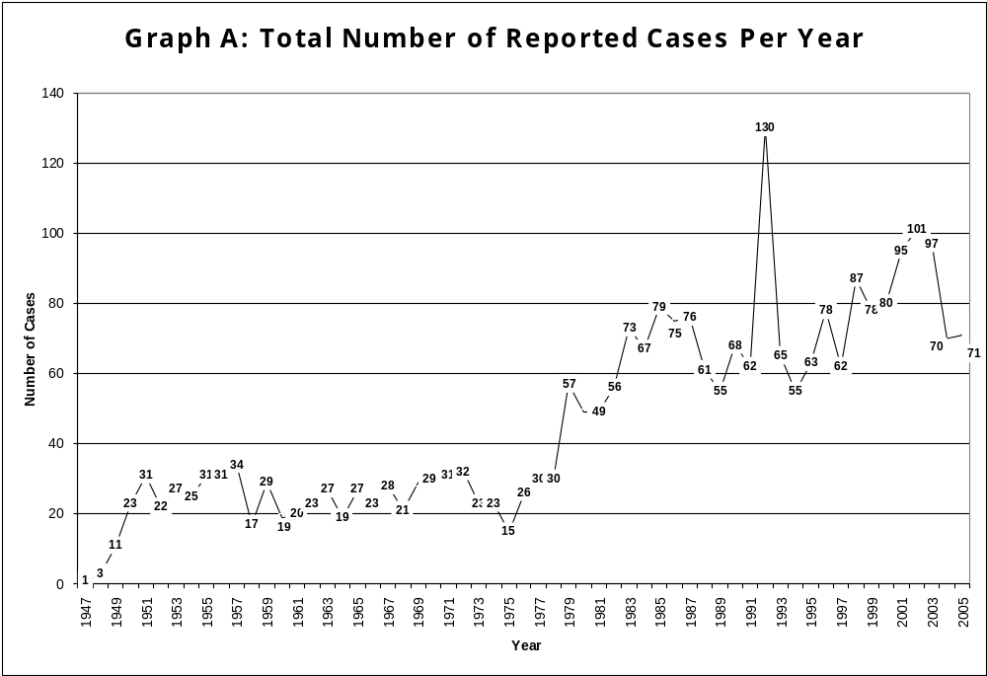
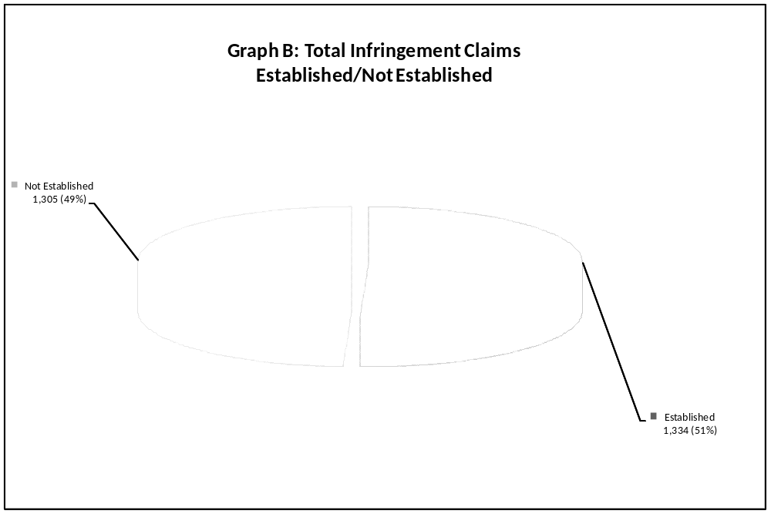

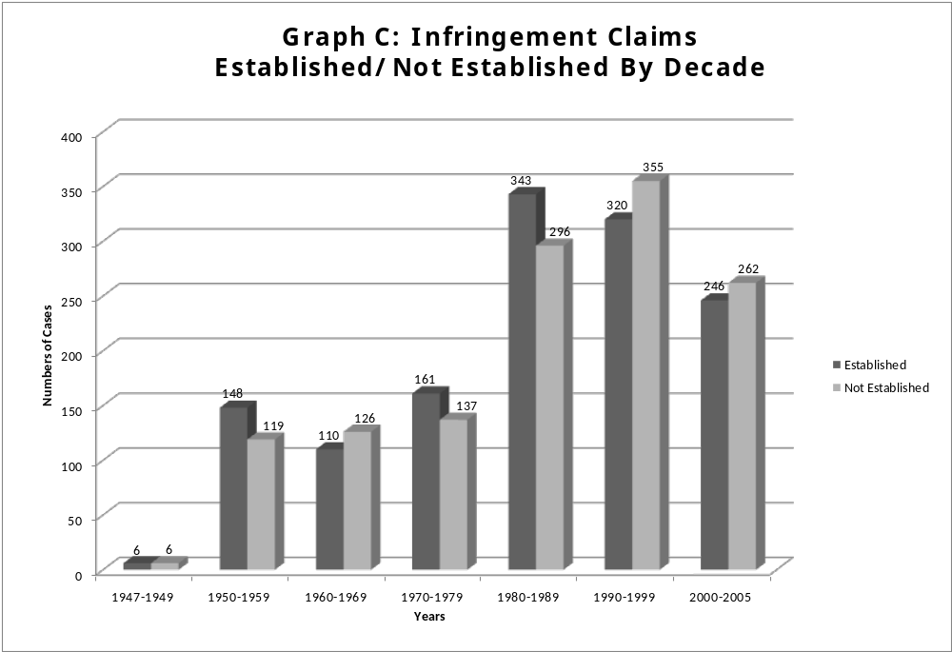

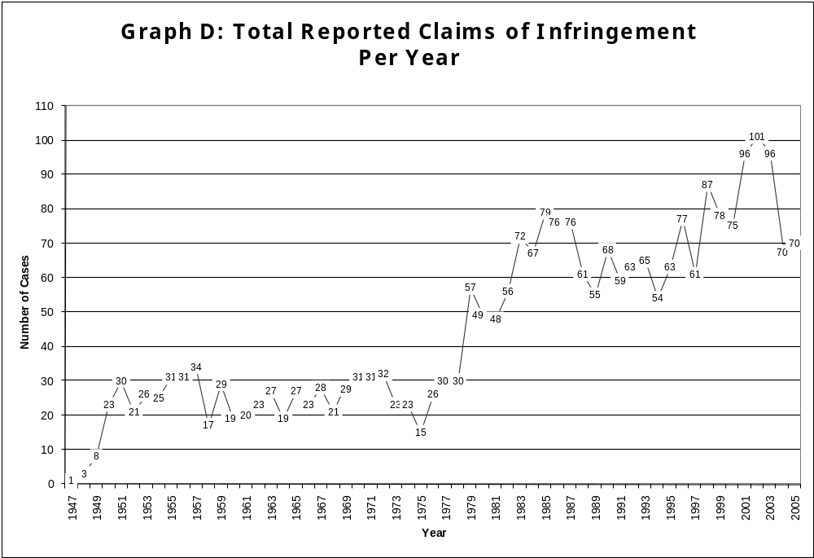
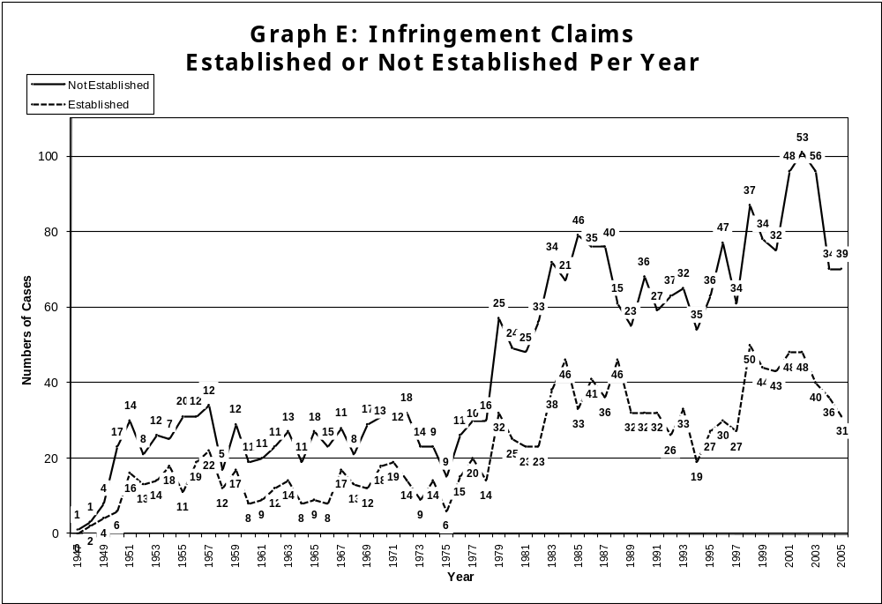
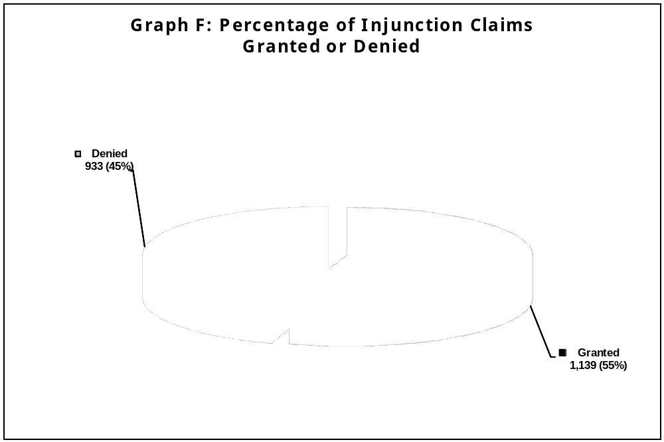
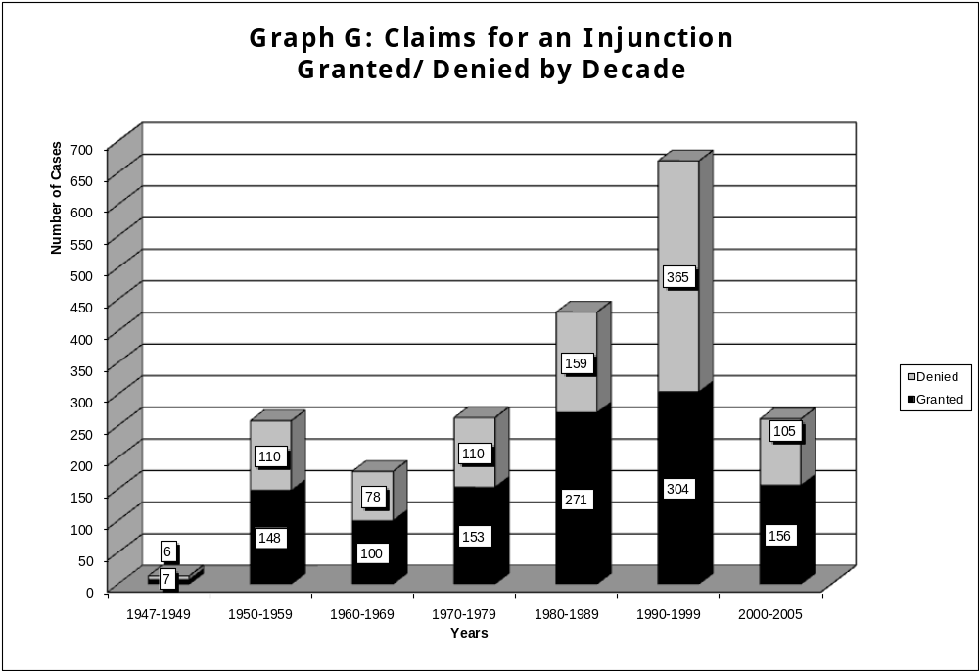
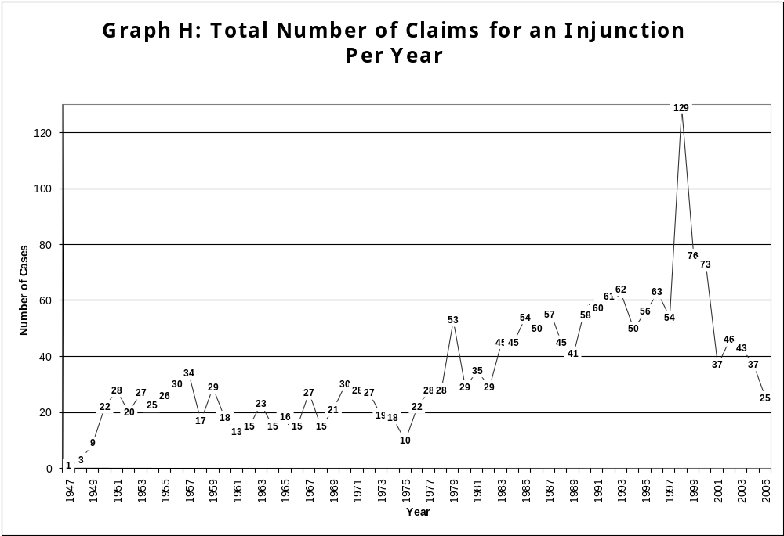
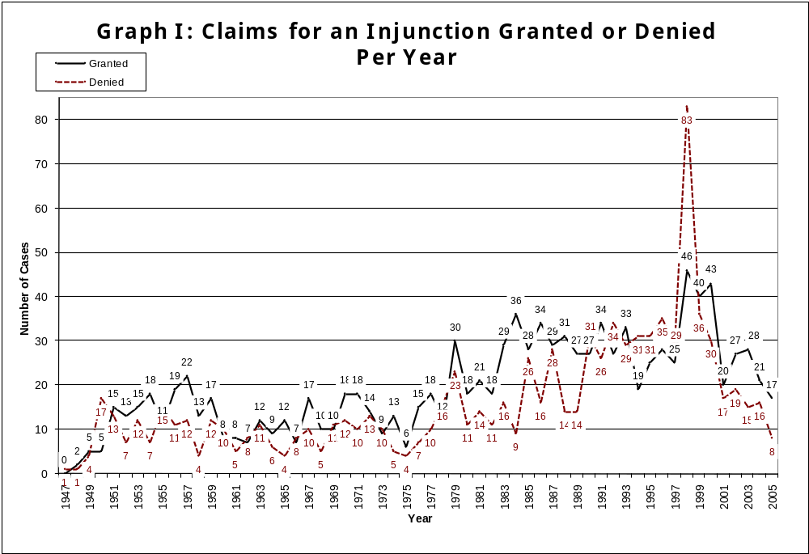
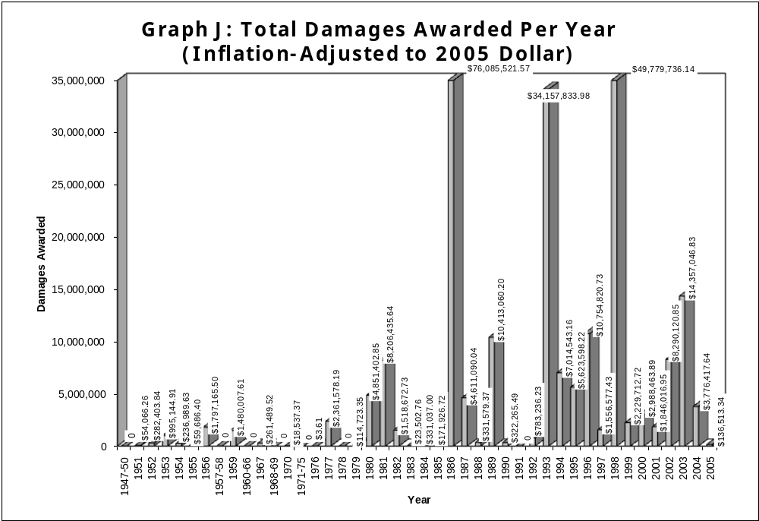
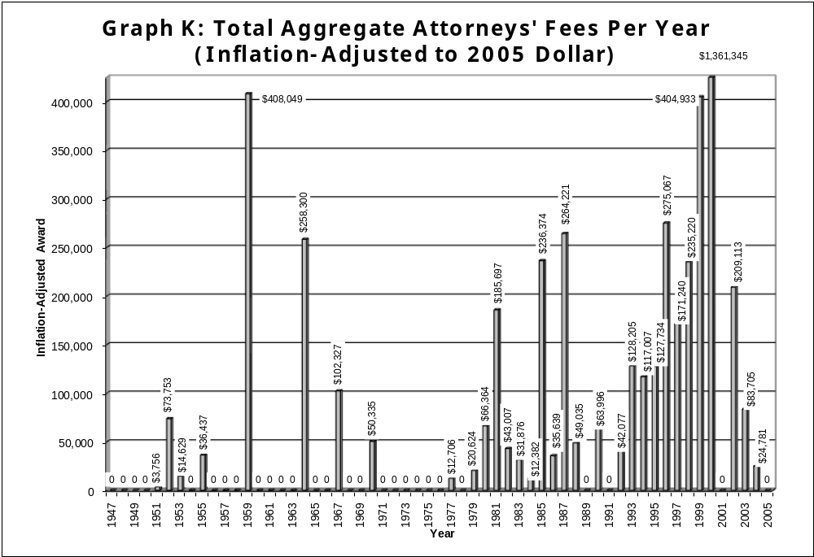
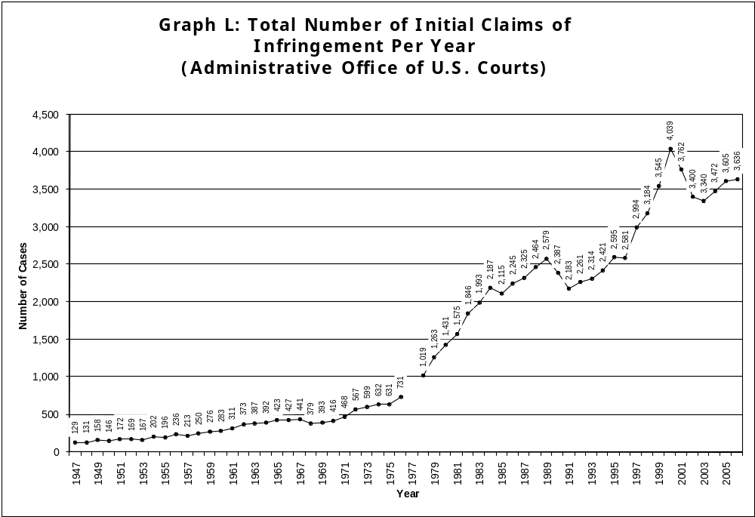

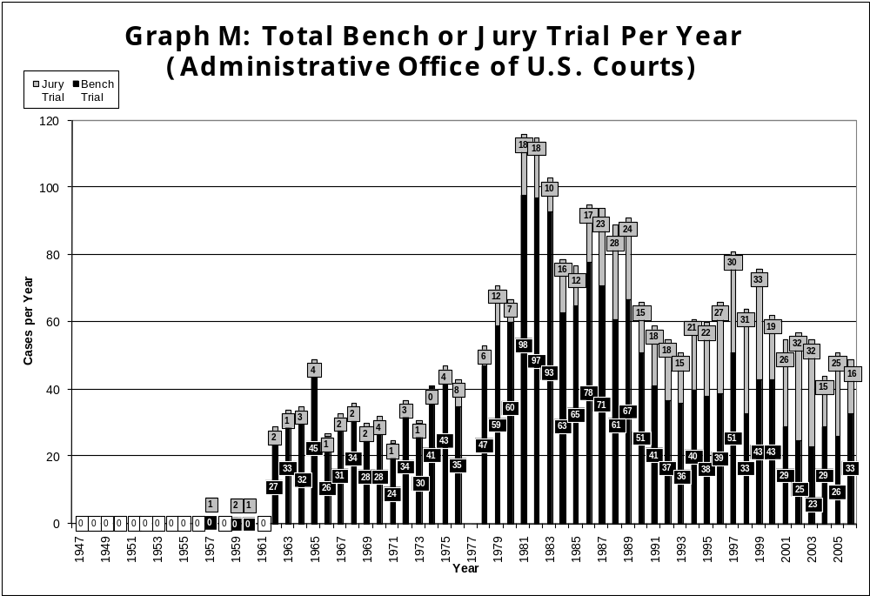
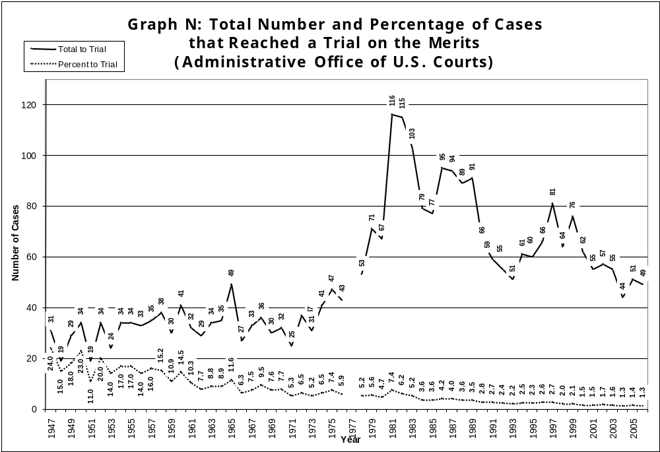
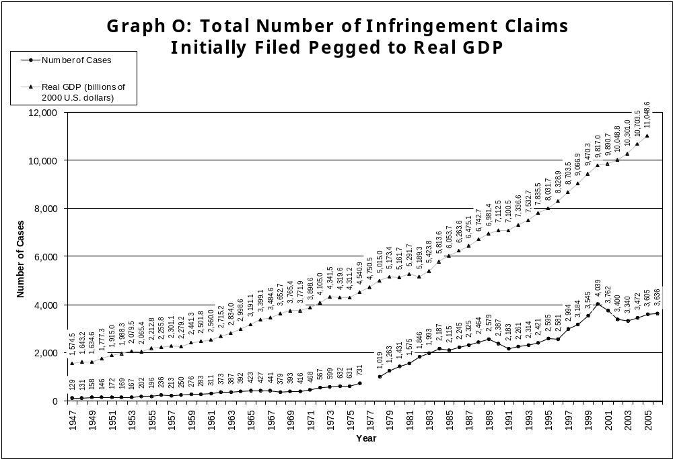
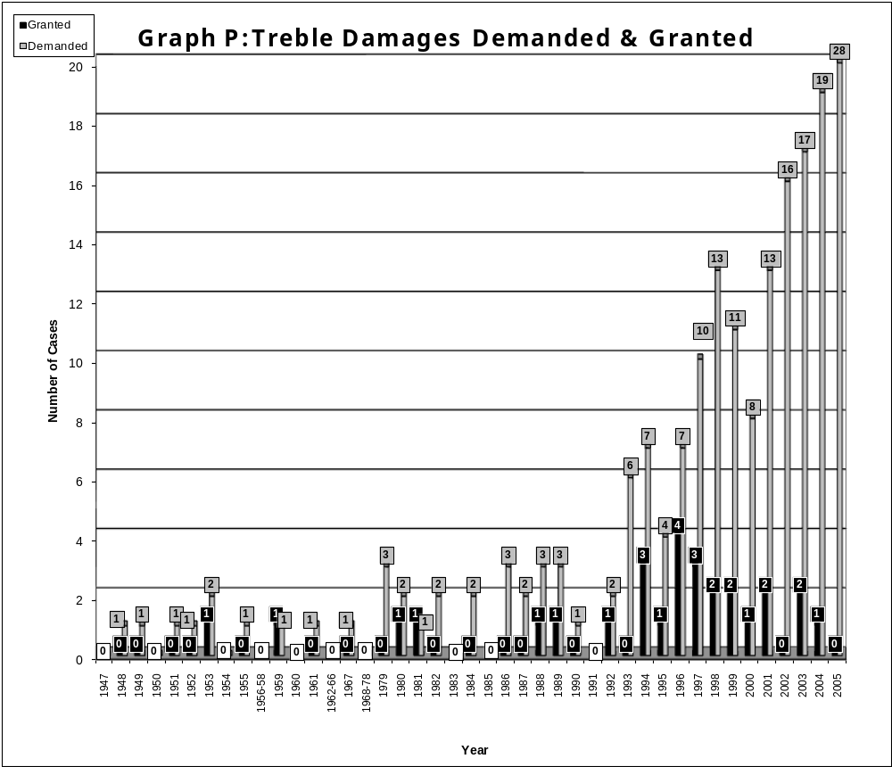
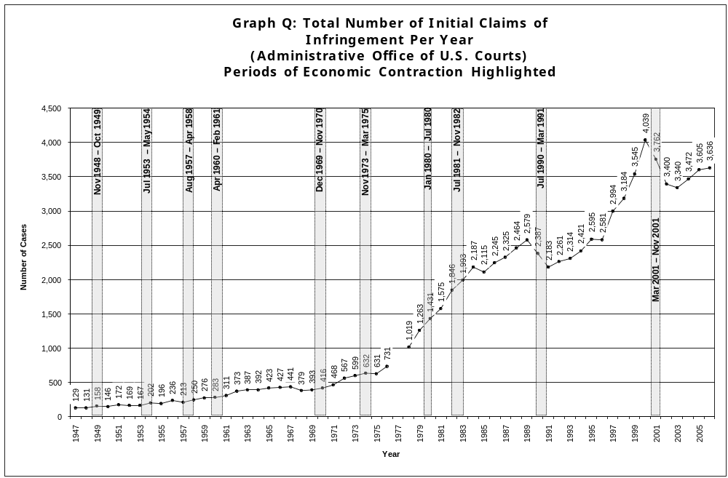
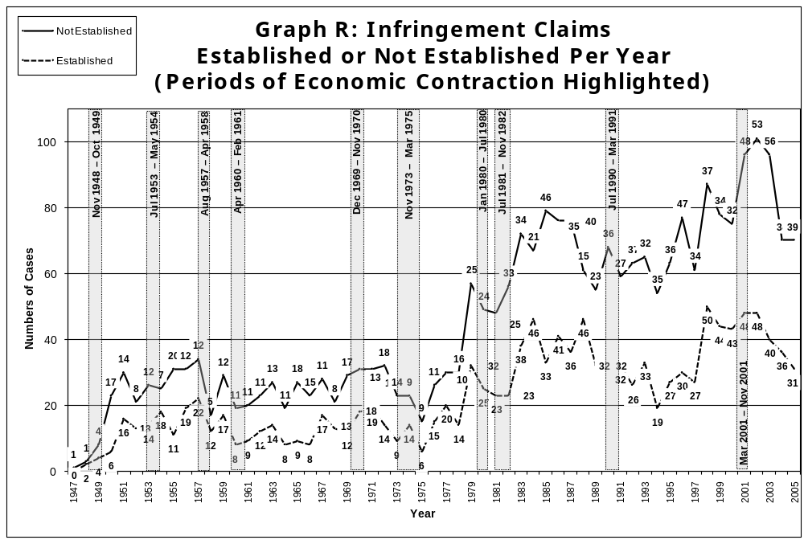
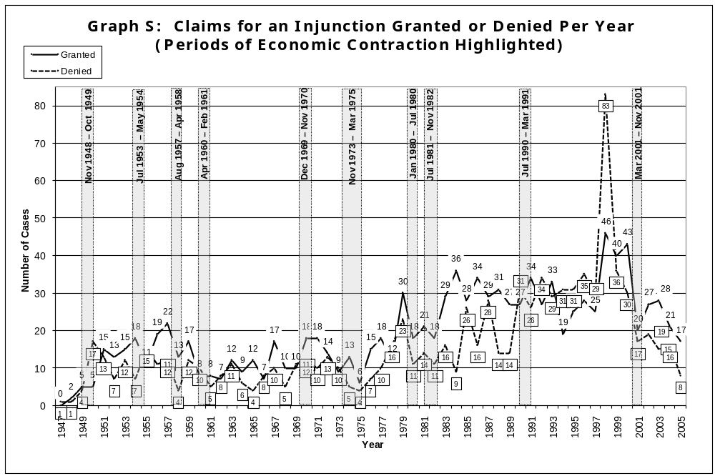
IV. Analysis: the End of Trademark Law
All of the data shown above leads to multiple conclusions; however, one conclusion stands out: trademark litigation has recognized a precipitous drop since 2001. All indicators demonstrate the free-fall plunge of trademark litigation. While the number of total incidents of trademark claims of infringement peeked at 101 in 2001, by 2005, that number had dropped to 70 or a 40% decline in four years. Regarding the total number of injunctions demanded, that number peeked in 1998 at 129 and fell to just 25 by 2005 or an 81% decline in seven years. The total amount of damages awarded annually also fell precipitously. The second highest aggregate total annual damage award occurred in 1998 at almost $50 million. By 2005, the aggregate of all damages awarded to all trademark litigants in America dropped to $136,513 or over a 99% decline.
On the other hand, the number of initial claims of trademark infringement filed per year is increasing.
To be sure, trademark litigation isn’t what it used to be.
Over the 58 year history of the Lanham Act for which there is data, 1,334 cases or 51% of all cases found for the claimant of infringement; 1,305 cases or 49% found no infringement. Regarding injunctions, there were 1,139 injunctions granted or 55% of the total and 933 injunctions or 45% denied. That is, over the entire life of the Lanham Act, a litigant has only marginally better than 50% chance of succeeding on the merits and only a 55% chance of obtaining an injunction when one is demanded.
Only 5.5% of all cases found any damages at all. The aggregate amount of damages awarded to all claimants under the 58 year life of the Lanham Act, adjusted for inflation, is $257,822,928. As there were 2,659 total cases, the average award of all cases is $96,962. That is, in any given trademark litigation, the average damage award is nearly $100,000.
However, of those 2,659 total cases, only 146 actually found any damages at all. Therefore, the average award of damages in cases where damages were actually awarded is $1,765,910. That is, if a court actually awards damages, the average amount of those damages is over $1.7 million.
There is a clear demarcation line at approximately 1980. In the decade that started in 1980 the incidents of trademark infringement, the number of injunctions demanded and the damage amounts went up drastically from prior years. From 1947 to 1979, inclusive, there were only 21 cases that found damages. From 1980 to 2005, inclusive, that number went to 125. Prior to 1980, the total amount of damages awarded to all claimants was $7,661,796 or, per year, an average of $364,847. The average damage award per year in cases 1980-2005 where damages were awarded was $2,001,289. Fully 1,199 of the 2,659 total cases, or 45% of all cases, are dated 1990 or later.
During the decade that ended in 1979, there were 298 total cases that claimed infringement. During the decade that started in 1980, there were 639 cases or more than double the previous decade. Decade to decade comparison of injunction data also shows a constant increase in both the overall number of cases where an injunction was demanded and the number succeeding in obtaining that injunction.
However, although all indicators in the database show a remarkable increase after about 1980, there is an equally remarkable decrease after about 2000. The only indicator that is currently on the rise is the number of cases initially filed, as reported by the Administrative Office of US Courts.
Regarding the aggregate annual damages awarded, there were three anomalous years. In the years 1986, 1993 1998, the total damages for just those three years was $160,023,092 or over 62% of all damages awarded over the 58 history of the Lanham Act in just three years. If the three anomalous years are excluded, the average damage award over the entire history of the Lanham Act drops from nearly $100,000 to just $36,822. However, if one excludes the anomalous years in cases 1980-2005 where damages were found, the average is $738,836.
Regarding attorneys’ fees, once again, there is a very high and anomalous spike in 2000 and then a fall off to zero by 2005. That is, in 2000 there were almost $1.4 million dollars awarded as attorneys’ fees. By 2005, that amount fell to zero. The anomalous years in damage awards of 1986, 1993 and 1998 is not replicated in the amounts of attorneys’ fees awarded. That fact seems to lead to the conclusion that large damage awards do not translate into large attorneys’ fees awards.
The Lanham Act also allows for treble damages. As with the general damages provisions under the Lanham Act, treble damages are very infrequently awarded. First, the trademark bar seems to have just discovered this provision in 1993. Previously, there was never a year when treble damages were demanded in more than three cases. In 1993, that doubled to six cases. However, in the 58 years of data, there is never a year where more than four demands for treble damages were granted. More importantly, the trend regarding the granting of treble damage award demands is clearly negative. That is, the number of awards of treble damages peaked in 1995 and 1996 at four and has been in decline since. In 2005, no awards of treble damages were made.
Regarding demands for treble damages, that data is increasing quite sharply. From six demands mad in 1996, by 2005 that had increased to 28. However, caution in reading this figure is in order. This increased number of demands may simply be a function of more information becoming available on Westlaw or Lexis. It may simply be that there were more demands made in previous years but no record of that demand was kept. One way or the other, there were no treble damages awarded in 2005.
The Federal Trademark Dilution Act took effect in 1996. Therefore, there is only 10 years of data regarding dilution cases. In that 10 years, there was a total of 218 cases where dilution was claimed. Only 22 cases, or 10%, of those 218 dilution cases exclusively claimed dilution. That is, 90% of dilution cases claimed dilution and infringement or dilution and cybersquatting.
Mirroring the overall trend, the number of dilution claims is shrinking. From a high year of 39 cases in 1998, by 2005 that number dropped to 9. In 2005, there were approximately 1/4 the number of claims there were in 1998.
Of course, in the Victoria’s Secret case, the United States Supreme Court made federal trademark dilution much more difficult to establish, holding that the test for dilution was “actual dilution”, not a merely likelihood of dilution. The result of that case has since been overturned by an act of Congress, however, the chilling effect on the number of dilution cases is obvious. In 2003, the year of the Victoria’s Secret case, there were 14 dilution cases. Although that number went up to 16 in 2004, it dropped to 9 in 2005. Regarding the cases where dilution was exclusively claimed, the effect of Victoria’s Secret seems more profound. While there were 5 cases in each of the years of 2000, 2001 and 2002 that exclusively relied on dilution under the FTDA, in 2003, the year of the Victoria’s Secret case that number went to 1, in 2004 there were 2 and in 2005 there was just one case.
Although the data indicates that there was already a downward trend in the number of dilution cases even before the Victoria’s Secret Case, the drop off to only 9 cases of 70 total reported trademark cases, or only 13%, seems to indicate that the trademark bar has become rather cautious about raising dilution under the FTDA.
After dilution claims peeked in 1998, there has been a general downward trend to the number of dilution claims made. It will be interesting to see if the Trademark Dilution Revision Act of 2006 has an affect on the number of dilution claims made, but the overall general trend to dilution claims seems to be that they occur less often. It may have been pent up demand or the novelty of the dilution cause of action that caused the larger numbers of dilution claims in the late 1990's, but it appears that there has been a general downward trend in dilution cases for 8 of the 10 years for which there is data.
In order to show trends in dilution data, the most important number to consider is the cases where only dilution is claimed. In these cases, presumably, the plaintiff seriously considered its mark diluted and did not just pile the claim onto other causes of action as dilution plaintiffs did in 90% of cases where dilution is claimed. Looking only at cases where dilution was exclusively claimed, the data reinforces the conclusion that that dilution is not a major source of litigation data and it is decreasing. There were only 22 cases in 10 years of effectiveness of the FTDA where dilution was exclusively claimed. Obviously, that is just more than two per year and roughly 10% of all dilution claims.
However, of those 22 cases, the claimant of dilution prevailed in just 9 cases and the defendant prevailed in 13 cases. That is, if a claimant brings an exclusive trademark dilution cause of action under the FTDA, that claimant prevails just under 41% of the time and loses nearly 60% of the time.
Trademark dilution cases happen rather infrequently. There were 218 total dilution claims (coupled with other causes of action) in the 10 year period of 1996-2005. This is only 24% of the total cases in the database for that time period. Furthermore, only 22 cases exclusively claimed dilution. Therefore, claiming dilution as a basis for a remedy in trademark litigation is, in reality, a rather rare event.
As an injunction is the principal remedy under the FTDA, it might be statistically significant that 34% of cases in the time period of 1996-2005 where an injunction was demanded raised dilution. However, 90% of these cases also claimed some other cause of action. The database does not support the conclusion that in everyone of these cases the injunction was based on the claim of dilution. In fact, the database is unclear precisely how many of these injunctions were granted on the dilution claim and how many were granted one of the other claims raised.
Furthermore, the significance of dilution seems to be shrinking. Again, in 2005, only 9 of 70 total cases or 13% claimed dilution at all and only one case exclusively claimed dilution.
That is, rather few cases actually claim dilution. Although the controversial nature of the theoretical justification of dilution in the United States as a federal cause of action has raised dilution to a position of academic prominence, it is clearly not prominent in reality. With only two exclusive dilution claims reported per year since the FTDA’s inception and where only a quarter of all cases reported claimed dilution at all, it is a far less significant cause of action than one might expect.
Even less significant is the ACPA. There is only six years of data available regarding cases that claim rights under the ACPA; however, this number, too, is quite small. There were only 29 cases from 2000-2005 that claim rights under the ACPA were violated and only 7 cases that exclusively claimed rights under the ACPA. Only 7% of all cases from 2000-2005 claimed rights under the ACPA .
Unlike other claims under the Lanham Act, however, the rate of claims under the ACPA seems constant. There have been five cases under the ACPA in both 2005 and 2004 and in 2003 there were seven. However, this means that under 10% of all cases per year claim rights under the ACPA.
The infrequency of exclusive claims under both the FTDA and the ACPA raises doubts about claims of their import. With so few exclusive claims under both the FTDA and the ACPA, this data seems to beg the question of are these causes of action as important and significant as claimed?
The statistics maintained by the Administrative Office of the US Courts paints a rather similar picture. Although the total number of trademark cases initially filed is increasing after reaching its peek in 1999 and then dropping until 2002, some other data maintained by US Courts is consistent with the findings reported here. Specifically, the number of cases that reach a trial peeked in 1980 at 116, but has a clear downward trend to only 49 in 2005. There was a sudden and extreme jump in cases that reached a trial on the merits in 1980 which is consistent with the findings reported here.
However, looking at the entire 58 years of data according to the US Courts, the total number of cases that reach trial, ignoring the high peeks in 1980, 1981 and 1983, seems to be rather constant. The average number of cases that made it to trial over the 58 years of data is approximately 53 cases per year. With 49 cases in both 1965 and 2005, this number has remained rather constant in the 60 year history of the Lanham Act.
Of course, as the number of cases initially filed has continually increased, and the number of cases that reach trial has remained constant, the average has, correspondingly, decreased. The high peeks of percentage of cases that made it to trial were in 1947 with 24% and 1950 with 23% By 2005, that percentage had dropped to 1.3%
The trend in whether a case is tried by a jury or a judge is also clear. Like all the rest of the data, although the total number of cases that reach a trial on the merits continues to go down, the number of cases tried to a jury remains relatively constant at about 1/3 after 1985. Prior to 1985, a jury trial on a trademark matter was a relatively rare event.
Another trend is quite clear. Although there are some down turns in the data that are not accompanied by a general economic recession in the United States, each recession is clearly followed by an immediate downturn in the data (or the downturn in data happens during a recession). Therefore, during and immediately after recessionary times, the total number of reported cases claiming infringement, the total number of cases where an injunction was demanded, and the total number of initial filings of law suits goes down. Naturally, there is a delay in the data because a trademark infringement case that reaches a trial on the merits takes years.
The official years where the US economy was in a contraction mode or in a recession are as appears in Table 4 below.
Table 4: Recessionary Periods
Recession start date | Recession end date
November 1948 | October 1949
July 1953 | May 1954
August 1957 | April 1958
April 1960 | February 1961
December 1969 | November 1970
November 1973 | March 1975
January 1980 | July 1980
July 1981 | November 1982
July 1990 | March 1991
March 2001 | November 2001

In years immediately after the end of a recessionary period, all indicators increase, except in the post 2001 era. During only the post 2001 era, all indicators (except the number of initial filings) continue to decrease even though the relative health of the economy improves. One would expect the indicators to increase post recession as they did in all other nine recessionary periods during the life of the Lanham Act.
Finally, size seems to matter. There were 86 cases in the database where at least one of the parties was listed on the Dow Stock Exchange. Of these, the company on the Dow prevailed nearly 75% of the time. Compared to all cases, the trademark claimant only prevailed about 50% of the time. The track record of outcomes of cases where a party is listed on the Dow is as follows:
American Express: 1 win, 1 loss
AT & T: 2 wins, 1 loss
Caterpillar: 1 win, 1 loss
Chrysler: 1 win
Eastman Kodak: 2 wins
Exxon: 4 wins, 3 losses
General Electric Company: 3 wins
General Foods: 2 wins, 1 losses
General Motors Corp: 8 wins, 1 losses
Goodyear: 2 wins, 2 losses
Hewlett-Packard: 1 win, 1 loss
Honeywell: 1 win
IBM: 2 wins
J.P. Morgan: 1 win
McDonalds: 5 wins, 2 losses
Microsoft: 7 wins, 2 losses
3M: 2 wins
Pfizer: 1 win
Philip Morris: 2 wins
Procter & Gamble: 4 wins, 1 loss
Sears Roebuck & Company: 5 wins, 3 losses
Texaco: 1 win
Union Carbide: 2 wins, 1 loss
Wal-Mart: 1 win
Walt Disney: 2 wins, 1 loss
Westinghouse Electric: 1 win, 1 loss

The database clearly supports the conclusion that companies that are listed on the Dow Stock Exchange have a significantly higher chance of succeeding on the merits than if the company is not listed on the Dow.
Therefore, if a trademark holder files a trademark case today, they have a slightly better than 50% chance of succeeding on the merits. They have a 55% chance of obtaining an injunction, if demanded. They have a 5.5% chance of receiving any damages at all. On average, they will obtain approximately $100,000 in damages. Looking at cases post 1980 where damages were awarded, they will receive over $2 million in damages, when damages are awarded at all.
That is, nearly all cases end without damages being awarded, but when they are, there is a rather significant windfall. However, in about 95% of the cases, there are no damages awarded. The claimant succeeds on the merits only about half the time.
In most recent times, all indicators in the database, the amount of damages awarded, the total number of infringement cases reported per year and the total number of cases where an injunction is demanded are all decreasing. This decrease continues during current relatively positive economic times. Historically, there has been a positive correlation between economic health and indicators of trademark litigation activity. As the economy improves, those indicators of trademark litigation activity increase. This has been true for nine out of ten post-recessionary times in the US during the lifespan of the Lanham Act. The only exception is the last recession in 2001. Today, we should be seeing increases in the trademark litigation indicators, but we do not. In fact, the trademark litigation indicators considered in this study are experiencing a precipitous fall.
This precipitous fall is occurring while the initial filings are increasing.
That the data continues to decrease even during positive economic times post 2001, leads to the conclusion that there are some other variables affecting the data that had not been there during the nine other post recessionary periods.
One variable is the increase in private dispute resolution methodologies. The rate of parties seeking help to resolve their disputes through non-judicial means is increasing and, more importantly, having a specific effect on how many cases get thoroughly adjudicated. This fact may be having a negative impact on the data that was less prevalent during other recessionary periods as ADR and the like have become much more readily available and popularly used in recent times.
Another variable is a perception that trademark litigation is more expensive now than during other post-recessionary periods. This actually is only slightly true. Using the Laffey Matrix adopted by many courts to determine reasonable attorney fees, an attorney with 20 plus years of experience received an average of $510 in 1994 per hour, adjusted for inflation. In 2007, that figure rose only to $614.
Using the AIPLA’s 2007 statistics on billing rates for all IP attorneys, the median rate in 2006 was $275. The AIPLA reports that the raw median billing rate for all IP attorneys in 1996 was $180, however, this is not adjusted for inflation. Using the CPI to adjust for inflation, that $180 is really $239 in 2007 dollars. Therefore, the billing rate of the median IP lawyer has gone up in the last decade but by a rather small amount. Regardless of this reality, the anecdotal perception that this rate is out of hand, though, may be having a chilling affect.
Another variable may be the increased use of non-US causes of action to settle a dispute. As TRIPs has taken effect, it may be that more US litigants are finding it more palpable to file the litigation in a non-US jurisdiction, where in the past they may have stretched jurisdictional issues to have the case heard in the United States.
Yet another variable may be the nature of litigation in general and trademark litigation more specifically. Some argue that whether trademark infringement is a question of law or fact may have an impact on trademark litigation.
Another variable is trademark extortion. One plausible explanation for the data is that trademark extortion is occurring. As the number of cases initially filed continues to go up, the percentage of cases that reach a trial on the merits, the total number of cases reported, the total amount of damages and the total number of cases where an injunction is demanded are all decreasing. Although the other components, to be sure, may account for some of this, trademark extortion suggests one answer.
If trademark holders were simply filing their law suits in other jurisdictions outside of the United States, the total number of cases initially filed would not be increasing. If trademark holders had sticker shock, the total number of cases would not be increasing. If trademark holders were simply choosing alternative means to settle their disputes, the total number of cases would not be increasing.
Therefore, the only variable that suggests an explanation of this data is trademark extortion. Trademark holders are encouraged to be predacious. They file suit with no intent to prosecute it to a conclusion on the merits. Therefore, the number of cases initially filed increase, but the number of cases that reach a trial on the merits remains constant and all other indicators free fall. This predatory conduct is leading to the end of trademark law, an end to the public resolution of conflict between trademark holders and an end to the rational use of the Lanham Act as a vehicle to define trademark rights in America. Perhaps American antitrust laws should be specifically amended to make trademark extortion illegal. Perhaps all trademark holders should be required to carry insurance, thereby destroying the cost aspect of defending a trademark law suit. If defendants were not motivated by actual or perceived financial concerns, they may elect to defend an alleged trademark infringement more vigorously.
Trademark predation, unless corrected, will also have the effect of allowing trademark holders to expand their trademark rights to claim a mark is famous and therefore be appropriate for a dilution cause of action. This fame will be gained not through use, as is required both by the Constitution and the Lanham Act, but through trademark extortion.

V. Conclusion
The data suggests that trademark extortion is real. This is established by the fact that although all indicators of trademark litigation activity increased in post recessionary periods in the past 58 years, after the most current recession, trademark litigation activity indicators are falling precipitously. Damage awards, attorney fee awards, number of reported, dispositive decisions all continue to decrease while the total number of cases initially filed continues to increase after the 2001 recession.
This extortion allows or will allow trademark holders to expand trademark rights based on extortion, not based on use as the Lanham Act and the Constitution requires.
Is the Lanham Act an extraordinary success? On one hand, with only roughly 50% of claimants prevailing in their infringement claims, the Lanham Act does seem remarkably balanced. Trademark infringement winners do not dominate trademark litigation like they do in proceedings before the Uniform Dispute Resolution Policy. Trademark litigation under the Lanham Act does seem to be a place where trademark disputants can and do find a reasonable outcome. Trademark holders do not dominate the landscape.
The question is, with trademark extortion, whether it will remain that way in the future.
Therefore, returning the Problem stated above, the data here suggests that Companies A, B and C, the existing companies in the orange juice market, will be incentivized to use their trademarks to individually extort Company D and make it as difficult as they can for Company D to gain market share. Companies A, B and C are encouraged to engage in predation because, to the extent they are successful, two good things will happen for them. First, Company D will find it that much more difficult to enter the orange juice market and, second, the scope of A, B and C’s trademarks will broaden as the Company Ds of the world acquiesce to their use. They acquiesce to their use because of actual or threatened trademark litigation. We know they do not actually litigate cases to a conclusion because all trademark litigation indicators are in a precipitous free fall. Only initial filings are increasing, indicating that these companies are filing suit, but they are not following through with the litigation.
Ultimately, this may lead to trademark rights being based on extortion, not based on use. Ultimately, unless corrected, this may lead to the end of trademark law as we know it.

Bio:
Professor of Law and Director of Intellectual Property Law Studies, William Mitchell College of Law. The following people provided significant research support for this project: Kurt Strovink, Laurie Sheen, Stephanie Budge, Martha Engel, Nicholas Hergott, Joshua Jones, Paul Godfread, Marsha Pernat, and Maureen Ventura. The following people provided significant administrative support: Cal Bonde and Meg Daniel. The following William Mitchell College of Law Reference Librarians also provided critical support: Bill Jack, Neal Axton and Jane Hopeman. I also received important feedback and critical analysis regarding this paper from the Intellectual Property Scholars Conference held at DePaul University Law School in August of 2007 and from the Foreign Women’s Lawyers Association in Tokyo, Japan in July of 2007.

In Rex R. Perschbacher and Debra Lyn Bassett, The End of Law, 84 B.U.L. Rev. 1 (2004), the authors claim that the increased privatization of the legal process through ADR or other settlement mechanisms leaves law privately, not publicly judged. Designating judicial opinions as “not for publication”, etc., further hinders society’s ability to view the workings of the judicial system. Therefore, it is truly an anomaly when cases are fully litigated and reach a published, precedent setting opinion. This seems to be perfectly parallel to the trademark law setting in America today and thus I borrow from the authors’ catchy title.
Act of July 5, 1946, ch. 540, 60 Stat. 427 (1946) (codified as amended at 15 U.S.C. §§ 1051-1141n (2006)).
Robert C. Denicola, Some Thoughts on the Dynamics of Federal Trademark Legislation and the Trademark Dilution Act of 1995, 59 Law and Contemporary Problems 75 (1996)(“Statutes are judged by how well they promote the goals or cure the mischiefs prompting their enactment”). But see, Jerome Gilson and Anne Gilson LaLonde, The Lanham Act: Time for a Face Lift?, 92 TMR 1013 (2002)(arguing that there should be a Trademark Review Commission put in place to standardize and modernize trademark law and perhaps leading to a single appellate body hearing all trademark appeals).
Suhejla Hoti, Michael McAleer, and Daniel Slottje, Intellectual Property Litigation Activity in the United States, 20 Journal of Economic Surveys 715 (2006).
Michael Barbaro and Julie Creswell, With Trademark in Its Pocket, Levi’s Turns to Suing Its Rivals, New York Times, January 29, 2007, at A1.
I use the term “holder” where others might use the word “owner.” The trademark right only extends to the right to exclude others from using a mark to the extent which the holder has used it and only for as long as the holder has used it, there is actually nothing to “own” in the technical sense. A trademark holder does not “own” the word. Therefore, Delta brand faucets and Delta brand airlines have co-existed for years. As such, using the term owner raises connotations that are not appropriate in trademark jurisprudence.
Abercrombie & Fitch Co. v. Hunting World, Inc., 537 F.2d 4 (2d Cir. 1976)(“A&F has spent large sums of money in advertising and promoting products identified with its mark ‘Safari’ and in policing its right in the mark, including the successful conduct of trademark infringement suits”).
Wallpaper Mfrs., Ltd. V. Crown Wallcovering Corp. 680 F.2d 755 (CCAP 1982).
Infringement is present when there is a likelihood of confusion between two marks. KP Permanent Make-Up, Inc. v. Lasting Impression I, Inc., 543 U.S. 111, 120 (2004). The traditional formulation of trademark infringement required there to be competition between the parties, that is, “commerce that could be regulated by Congress”. See U.S. Cont. Art. I, sec. 8 cl. 3. This provision has long been thought to be the constitutional justification of trademarks after the U.S. Supreme Court held that the Patent and Copyright Clause, Art. I, sec. 8, cl. 8, could not be used to justify federal protection of trademarks. The Trademark Cases, 100 U.S. 82 (1879). Recently, there seems to be some “mission shift” as some courts are not requiring there to be competition before finding a likelihood of confusion. See, e.g., Anheuser-Busch, Inc. v. Balducci Publ'ns, 28 F.3d 769, 774 (8th Cir. 1994) (“[C]onfusion . . . may exist in the absence of direct competition.” Court finds likelihood of confusion between humor magazine's parody and beer maker's trademarks). Originally and constitutionally, without competition there could be no likelihood of confusion and therefore no infringement. That is, “one merchant shall not divert customers from another by representing what he sells as emanating from the second.” See, Yale Elec. Corp. v. Robertson, 26 F.2d 972, 973 (2d Cir. 1928). Under the Lanham Act, trademark infringement is governed by 15 U.S.C. Sec. 1114 (2006), but this provision neither mentions “likelihood of confusion” nor defines it in any way.
Trademark dilution occurs when the use of a trademark by another “lessen[s] the capacity of a famous mark to identify and distinguish good or services, regardless of [competition or likelihood of confusion]”. 15 U.S.C. Sec. 1127 (2006). See also, Moseley v. V Secret Catalogue, 537 U.S. 418, 433 (2003).
This article concentrates on Article III court proceedings, however, a similar argument can be made about trademark oppositions and cancellations before the PTO, an administrative body. For example, there were over 6,500 oppositions filed in calendar year 2006. Performance and Accountability Report: Fiscal Year 2006, table 23, http://www.uspto.gov/web/offices/com/annual/. However, over 95% of these will result in settlement or dismissal prior to a final disposition. OPPOSITION PROCEEDINGS BEFORE THE PATENT & TRADEMARK OFFICE TRADEMARK TRIAL AND APPEAL BOARD Roberta S. Bren SC68 ALI-ABA 183OPPOSITION PROCEEDINGS BEFORE THE PATENT AND TRADEMARK OFFICE TRADEMARK TRIAL AND APPEAL BOARD EXHIBITS Roberta S. Bren SC68 ALI-ABA 375.
Accurate Merchandising, Inc. v. American Pacific, 186 U.S.P.Q. (BNA) 197 (1975). This statute places an affirmative duty upon a licensor of a registered trademark, such as TELE-TENDER to take reasonable measures to detect and prevent misleading uses of his trademark by his licensees or suffer cancellation of his federal registration. 15 U.S.C. § 1064 provides that a trademark registration may be cancelled because the trademark has been ‘abandoned.’")
Wallpaper Mfrs., Ltd. V. Crown Wallcovering Corp. 680 F.2d 755 (CCAP 1982)
Hermes Int'l v. Lederer de Paris Fifth Avenue, Inc., 219 F.3d 104, 110 (2d Cir. 2000).
Ty Inc. v. Softbelly's, Inc., 353 F.3d 528, 531 (7th Cir. 2003)(For example, “Ty polices the use of ‘Beanie(s)’ vigorously by filing lawsuits, sending cease and desist letters, and opposing trademark applications for the word or its cognates”).
See, e.g., http://www.keytlaw.com/urls/c&d.htm.
Microsoft filed 235 trademark infringement law suits in the years 2001-2005. Michael Barbaro and Julie Creswell, With Trademark in Its Pocket, Levi’s Turns to Suing Its Rivals, New York Times, January 29, 2007, at A1.
Even when not an apparent strike suit because the plaintiff does seek to litigate the case to a final decision on the merits, the trademark holder only prevails about half of the time.
See Behlen v. Merrill Lynch, 311 Fd. 3d 1087, 1091 n.1 (11th Cir. 2002)(“A strike suit is defined as ‘[a] suit . . . often based on no valid claim, brought either for nuisance value or as leverage to obtain a favorable or inflated settlement.’ quoting Black's Law Dictionary 1448 (Bryan A. Garner ed., 7th ed. 1999).
http://www.uscourts.gov/judbus2006/appendices/c4.pdf; infra Graph N.
See sources cited in Rex R. Perschbacher and Debra Lyn Bassett, The End of Law, 84 B.U.L. Rev. 1 n1. (2004).
See infra Graph N.
See infra Graph L.
This is the practice of filing petitions to cancel registered marks or to oppose the registration of trademark applications. These proceedings are not Article III style court proceedings but rather administrative proceedings before the Trademark Trial and Appeal Board (TTAB). See TTAB Manual of Procedure, http://www.uspto.gov/web/offices/dcom/ttab/tbmp/index.html.
Abercrombie & Fitch v. Hunting World, Inc., 537 F.2d 4 (2d Cir. 1976).
15 U.S.C. Sec. 1125( c )(1)(A)(2006)(“For purposes of paragraph (1), a mark is famous if it is widely recognized by the general consuming public of the United States as a designation of source of the goods or services of the mark's owner. In determining whether a mark possesses the requisite degree of recognition, the court may consider all relevant factors, including the following: (i) The duration, extent, and geographic reach of advertising and publicity of the mark, whether advertised or publicized by the owner or third parties. (ii) The amount, volume, and geographic extent of sales of goods or services offered under the mark. (iii) The extent of actual recognition of the mark. (iv) Whether the mark was registered under the Act of March 3, 1881, or the Act of February 20, 1905, or on the principal register”).
15 U.S.C. Section 1227(2006)(“The term “dilution” means the lessening of the capacity of a famous mark to identify and distinguish goods or services, regardless of the presence or absence of - (1) competition between the owner of the famous mark and other parties, or (2) likelihood of confusion, mistake, or deception”).
The constitutional requirement of use comes from the Lanham Act’s reliance on the Commerce Clause for its legitimacy. See U.S Constitution, Art. I, sec. 8 cl. 3 and 15 USC Section 1058 (2006).
Richard A. Posner, Economic Analysis of Law (2d ed. 1977).
Nicholas A. Widnell, COMMENT: The Crystal B al of Innovation Market Analysis in Merger Review: An Appropriate Means fo Predicting the Future?, 4 Geo. Mason L. Rev. 369, 373-74 (1996).
Michael Barbaro and Julie Creswell, With Trademark in Its Pocket, Levi’s Turns to Suing Its Rivals, New York Times, January 29, 2007, at A1.
For an excellent and readable history of the notion of trademark protection in the United States, see Keith M. Stolte, A Response to Jerome Gilson’s Call for an Overhaul of the Lanham Act, 94 Trademark Reporter 1335 (2004).
Beverly W. Pattishall, Two Hundred Years of American Trademark Law, 68 Trademark Rep. 121 (1977).
Journal of the House, p. 464 (1791).
Edward Rogers, Good Will, Trade-marks and Unfair Trading 47-48 (1919); Beverly W. Pattishall, The Constitutional Foundations of American Trademark Law, 78 TRADEMARK REP. 456, 459 (1988) (citing to Am. State Papers 48).
Justin Hughes, Copyright and Incomplete Historiographies, 79 S. Cal. L. Rev. 993, 1033 (2006). Jefferson has even been called the “Father of American Trademark.” http://www.lib.utexas.edu/engin/trademark/timeline/tj/tj.html. See also, Beverly W. Pattishall, Two Hundred Years of American Trademark Law, 68 Trademark Rep. 121, 122 (1977).
Thomas Jefferson, Report on the policy of securing particular marks to Manufacurers, by law, in 3 WRITINGS OF THOMAS JEFFERSON 156-57 (Andrew A. Lipscomb ed., 1905)(Jefferson limited any trademark law to “commerce with foreign nations, and among the several States, and with the Indian tribes,” tracking the Commerce Clause verbatim). See also Keith M. Stolte, A Response to Jerome Gilson’s Call for an Overhaul of the Lanham Act, 94 Trademark Reporter 1335, 1340 (2004).
Thomas Jefferson, Report on the policy of securing particular marks to Manufacurers, by law, in 3 WRITINGS OF THOMAS JEFFERSON 156-57 (Andrew A. Lipscomb ed., 1905)(trademark protection would “contribute to fidelity in the execution of manufacturing” and “rendering it penal in others to put the same mark to any other wares”).
Beverly W. Pattishall, The Constitutional Foundations of American Trademark Law, 78 TRADEMARK REP. 456, 460 (1988); Edward Rogers, Good Will, Trade-marks and Unfair Trading 48 (1919)(“It is evident that there was not a sufficient demand at the time of Jefferson's report or for seventy-nine years afterwards for a law to put into effect his recommendations and it was not until 1905 that they were fully carried out.”). New York was the first state to enact a trademark law ostensibly to prevent fraud in the use of false stamps and labels, but did not do so until 1845. Id
Beverly W. Pattishall, The Constitutional Foundations of American Trademark Law, 78 TRADEMARK REP. 456, 459 (1988).
Trademark Act, ch. 230, 16 Stat. 198 (1870).
US Cont., Art. I, sec. 8, cl. 8.
US Cont., Art. I, sec. 8, cl. 8.
The Trademark Cases, 100 U.S. 82 (1879). Most relevantly for the subsequent Act of 1881, the Supreme Court expressly stated that its holding did not effect Congress’s ability to regulation international commerce. Id. at 99 ("In what we have here said we wish to be understood as leaving untouched the whole question of the treaty-making power over trade-marks, and of the duty of Congress to pass any laws necessary to carry treaties into effect.").
The Trademark Cases, 100 U.S. 82, 93 (1879). Reading the legislative history of the Lanham Act, one clearly gets the sense that the drafters were searching for Constitutional legitimacy. Hearings on H.R. 9041 Before the House Comm. on Patents, Subcomm. on Trade-Marks, 75th Cong., at 24 (1938)(“[A]nyone examining the history of the Federal Government can observe that, as a matter of fact, from the earliest beginnings of the United States and the Colonies preceding it, there has been a continual transfer of rights from the individual States to the Federal Government.”).
Although there had been several piece-meal attempts at trademark statutes, the 1905 Act was considered the first systematic trademark jurisprudence after the 1870 Act. See Trademark Act, 19 Stat. 141 (1876); Trademark Act, ch. 138, 21 Stat. 502 (1881)(applying only to international commerce).
Edward S. Rogers, The Expensive Futility of the United States Trade-Mark Statute, 12 MICH. L. REV. 660, 665 (1914). Rogers, probably not coincidentally, was the author of a trademark bill submitted to Congress in 1924 to supplant the Act of 1905. It, however, did not pass. See, Beverly W. Pattishall, The Constitutional Foundations of American Trademark Law, 78 TRADEMARK REP. 456, 462 (1988). For a more favorable review of the 1905 Act, see Robert P. Merges, One Hundred Years of Solicitude: Intellectual Property Law 1900-2000, 88 Calif. L. Rev. 2187, 2210 (2000)(“The 1905 Trademark Act - also premised on the Commerce Clause - finally remedied the situation, bringing clarity and uniformity to trademark law in accordance with the needs of the burgeoning consumer-products industries”).
Hearings on H.R. 9041 Before the House Comm. on Patents, Subcomm. on Trade-Marks, 75th Cong. 1-199 (1938). This was the initial hearing that took place on March 15th, 16th 17th and 18th of 1938. Representative Lahnam Chaired this Committee. It consisted of a fact finding mission where the House Committee acted as jurors getting to the truth of what became the Lanham Act. Of course, the presenters were all well-known trademark attorneys and corporate representatives who testified that, from their perspective and their clients perspectives, this national trademark law was needed. Only trademark holders or their representatives testified.
S. Rep. No. 79-133, at 6 (1946), reprinted in 1946 U.S.C.S. 1274.
S. Rep. No. 79-133, at 6 (1946).
S. Rep. No. 79-133, at 6 (1946).
S. Rep. No. 79-133, at 7 (1946).
S. Rep. No. 79-133, at 7 (1946).
S. Rep. No. 79-133, at 7 (1946).
60 Stat 443 (1946)(codified at 15 U.S.C.A. § 1051-1141n).
The first case to cite the Lanham Act was Anheuser-Busch, Inc. V. Du Bois Brewing Co, 73 F. Supp. 338 (W.D. Penn. 1947) on September 9, 1947. The first case to actually rely on the Lanham Act was California Fruit Growers Exchange v. Sunkist Baking Co., 166 F.2d 971 (7th Cir. 1947) on December 23, 1947 reversing a finding of infringement of the word SUN-KIST as no confusion as to source was found as required under the Lanham Act. Needless to say, this case was originally filed before the effective date of the Lanham Act. The court in this case does not give the date of the case from which this appeal was brought but does also cite the Act of 1905 for the proposition that allowing the plaintiff to monopolize the word “sun-kist” on food products would be giving them too much. The first actual reported district court case relying on the exclusively on the Lanham Act for jurisdiction is Colonial Radio Corp. v. Colonial Television Corp., 78 F. Supp. 546 (S.D.N.Y. 1948) on June 8, 1948, almost exactly 11 months after the effective date of the Lanham Act. Furthermore, this case was successful in enjoining the defendant from using COLONIAL on televisions while the plaintiff had used it on or in connection with radios. In the first two years of the Lanham Act’s existence, there are eight reported substantive cases citing the Lanham Act as controlling.
Elke Elizabeth Werner, Comment: Are We Trading Our Lanham Act Away? An Evaluation of Conflicting Provisions Between the NAFTA and North American Trademark Law, 2 Sw. J.L. & Trade Am. 227 (1995)(“Trademarks ‘encourage competition, promote economic growth and can raise the standard of living of an entire nation’”)" quoting S. Rep. No. 515, 100th Cong., 2d Sess. 5 (1988).
Actually, it was only 8 years after the statute was first submitted in 1938, but for more than 10 years it was studied, analyzed by a standing committee of the ABA. Hearings on H.R. 9041 Before the House Comm. on Patents, Subcomm. on Trade-Marks, 75th Cong., at 11 (1938).
Edward S. Rogers, The Expensive Futility of the United States Trade-Mark Statute, 12 MICH. L. REV. 660, 665 (1914).
Keith M. Stolte, A Response to Jerome Gilson’s Call for an Overhaul of the Lanham Act, 94 TMR 1335, 1349 (2004).
Robert C. Denicola, Some Thoughts on the Dynamics of Federal Trademark Legislation and the Trademark Dilution Act of 1995, 59 Law and Contemporary Problems 75, 79 (1996).
Edward S. Rogers, Introduction in D. Rober, The New Trade-Mark Manual, at ix (1947)(“The Lanham Act is the latest development in the long, slow, and sometimes dicouraging process of the effort to protect trade-marks. . . ). See also H.R. Report No. 79-2322, at 7524 (Statement of Mr. Laham: “[T]he legislative history of this act is long and extensive”).
Sigmund Timberg, Trade-Marks, Monopoly , and the Restraint of Competition, 14 Law & Contemp. Prob. 323, 347 (1949)(The Lanham Act “is inspired by divergent philosophical theories of trade-mark protection which were not effectively reconciled”). See also, Daniel McClure, Trademarks and Unfair Competition: A Critical History of Legal Thought, 69 Trademark Reporter 305,334 (1979)(“Despite its pretension oto bringing orderliness to trademark law by restating and modernizing the law, in many ways the Lanham Act did not sovle the key controversies in trademark an d unfair competition, leaving the courts in much the same position as before”). See also H.R. Report No. 79-2322, at 7524 (Statement of Mr. Laham: “[The Lanham Act] reenacts much prior legislation and creates new rights. . . ”).
Daniel McClure, Trademarks and Unfair Competition: A Critical History of Legal Thought, 69 Trademark Reporter 305,334 (1979).
The original Bill was considered to pre-empt the State law of trademarks. Hearings on H.R. 9041 Before the House Comm. on Patents, Subcomm. on Trade-Marks, 75th Cong., at 14 (1938).
See Steven Carter, The Trouble with Trademarks, 99 Yale L. J. 759, 775-76 (1990)(“the Lanham Act ultimately marked a rather dramatic departure from the common law. The breadth of common law protection varied roughly with investment, so that rights extended to all of the geographic areas, but only those areas, in which the holder had actually used the mark to identify its goods or into which the firm would naturally expand. Elsewhere, anyone was free to use the mark. The legislative history may suggest that the Lanham Act is to operate under similar restrictions, prohibiting only ‘diversion of trade through misrepresentation,’ but that is not how the statute reads. Under the literal terms of the Act, the protection of a registered mark goes beyond mere misrepresentation, because it is not limited to the particular geographic regions in which the registrant does business. On the contrary, registration serves as constructive notice everywhere in the country of the registrant's claim of ownership, and unless that claim can be overcome, the substantive rights conferred by registration are nationwide in scope.”).
Hearings on H.R. 9041 Before the House Comm. on Patents, Subcomm. on Trade-Marks, 75th Cong. at 12 (1938).
Hearings on H.R. 9041 Before the House Comm. on Patents, Subcomm. on Trade-Marks, 75th Cong., at 22 (1938).
Hearings on H.R. 9041 Before the House Comm. on Patents, Subcomm. on Trade-Marks, 75th Cong., at 22 (1938).
U.S. Const. Art. I, sec. 8, cl. 3.
In Steele v. Bulova Watch Co., the Supreme Court held that "commerce" under the Lanham Act includes the extends to the limits of Congress' Commerce Clause powers. See also Planned Parenthood Fed'n of Am., Inc. v. Bucci, No. 97-0629, 1997 U.S. Dist. LEXIS 3338, at 10-11 (S.D.N.Y. Mar. 19, 1997) (explaining that "it is well settled that the scope of "in commerce' as a jurisdictional predicate of the Lanham Act is broad and has a sweeping reach") (citing Steele v. Bulova Watch Co., 344 U.S. 280, 283 (1952)).
See Michael Comiskey, Can a President Pack–or Draft–the Supreme Court? FDR and the Court in the Great Depression and World War II, 57 Alb. L. Rev. 1043, 1046 (1994).
See Michael Comiskey, Can a President Pack–or Draft–the Supreme Court? FDR and the Court in the Great Depression and World War II, 57 Alb. L. Rev. 1043, 1047 (1994).
Known as the “switch in time that saved nine.”
See Michael Comiskey, Can a President Pack–or Draft–the Supreme Court? FDR and the Court in the Great Depression and World War II, 57 Alb. L. Rev. 1043, 1046-47 (1994).
Deborah A. Ballam, The Evolution of the Government-Business Relationship in the United States: Colonial Times to Present, 31 American Business Law Journal 553, 632 (1994); Leon H. Keyserling, New Deal Symposium: The New Deal and its Current Significance In Re National Economic and Social Policy, 59 Wash. L. Rev. 795, 283-84 (1984).
Hugh Rockoff, World War II and the Growth of the U.S. Federal Government, in 11 Japan and the World Economy 245-262 (1999)(finding that the overall number of employees of federal agencies increased dramatically during the war, that many war-related emergency agencies were ultimately terminated soon after the war, that no ratcheting of the number of federal government agencies occurred because of the war, but a huge ratcheting of ideas about the importance of a large federal government to the national economy was realized).
S. Rep. No. 79-1333, at 5 (1946), reprinted in 1946 U.S.C.C.A.N. 1274, 1276-77
Park ‘N Fly, Inc. v. Dollar Park And Fly, Inc., 469 U.S. 189, 193 (1985).
Bartholomew H. Sparrow, From the Outside In: World War II and the American State 269 (1996)(“The war transformed the bureaucracies of the federal government; it reconfigured the pattern of government-society relations; and it altered the means of public administration wtih respect to social welfare material procurement by the Navy Department.”).
Bruce Seely, Building the American Highway System: Engineers as Policy Makers 178 (1987)(One of the first highway projects under the plan called Toll Roads and Free Roads, a federally sponsored systematic mapping of road construction that influenced road building for a decade across the United States, was to builds roads large enough to ferry 50,000 people a day to and from the Pentagon in 1941). For an interesting and brief review of how the war effort contributed to the development of a national highway system, see http://www.globalsecurity.org/military/facility/ndhs.htm
Gerald D. Nash, The American West Transformed 19 (1985)(The United States government invested huge sums of capital in the Westerns states during World War II to transform it into a livable, modern state).
Deborah A. Ballam, The Evolution of the Government-Business Relationship in the United States: Colonial Times to Present, 31 American Business Law Journal 553, 631 (1994).
Kermit Hall, The Magic Mirror: Law in American History 297(1989).
Deborah A. Ballam, The Evolution of the Government-Business Relationship in the United States: Colonial Times to Present, 31 American Business Law Journal 553, 629 (1994).
Deborah A. Ballam, The Evolution of the Government-Business Relationship in the United States: Colonial Times to Present, 31 American Business Law Journal 553, 629 (1994).
Deborah A. Ballam, The Evolution of the Government-Business Relationship in the United States: Colonial Times to Present, 31 American Business Law Journal 553, 629 (1994).
Until the Bush Administration, the PTO was considered a rather independent agency, free of direct political control of the President. Today, as the President appoints loyal but unqualified people to head up the PTO, significant litigation has resulted between the American Intellectual Property Law Association and the President. _______________
Daniel M. McClure, Trademarks and Competition: The Recent History, 59 Law and Contemporary Problems 13 (1996).
William M. Landes & Richard A. Posner, The Economics of Trademark Law, 78 Trademark Reporter 267, 270 (1986); Richard A. Posner, The Chicago School of Economics
Daniel M. McClure, Trademarks and Competition: The Recent History, 59 Law and Contemporary Problems 13 (1996).
Mark Crain and Asghar Zardkooki, X-inefficiency and Nonpecuniary Rewards in a Rent-Seeking Society: A Neglected Issue in the Property Rights Theory of the Firm, 70 The American Economic Review 784(1980)(Where potential monopolies (regulated or otherwise) are available to privately owned firms, resources devoted to appropriating these property rights are simply a form of "investing" or bidding to acquire the monopoly rights. This bidding behavior would be affected, of course, by the expected payoff to the holders if such rights are obtained. One consequence of rent seeking is that holders have incentives to redistribute wealth to reward those individuals with political power to grant monopoly status); Shabtai Donnenfeld and Shlomo Weber, Limit Qualities and Entry Deterrence, 26 The RAND Journal of Economics 113 (1995)(managers in oligopolistic manufacturing and services industries attribute to product location and product proliferation as entry-deterring strategies).
D.G. Hartle, The Theory of Rent Seeking, 16 The Canadian Journal of Economics 539-554 (1983); Kai A. Konrad and Harris Schlesinger, Risk Aversion in Rent-Seeking and Rent-Augmenting Games, 445 The Economic Journal 1671 (1997).
42 U.S.C.A. 1395cc-dd (West Supp. 1992)(federal "anti-dumping" law). See generally, Klaus Stegemann, Anti-Dumping Policy and the Consumer, 19 J. World Trade 466 (1990)
Steven C. Salop and David T. Scheffman, Raising Rivals’ Costs, 73 The American Economic Review 267-271 (1983); Michael Waldman, Noncooperative Entry Deterrence, Uncertainty, and the Free Rider Problem, 54 The Review of Economic Studies 301(1987)(For certain types of entry deterring investments the introduction of uncertainty causes the oligopoly to underinvest in entry deterrence).
Paul Milgrom and John Roberts, Predation, Reputation, and Entry Deterrence,, Journal of Economic Theory 27 (1982).
Steven C. Salop and David T. Scheffman, Raising Rivals’ Costs, 73 The American Economic Review 267-271 (1983). See also, Steven C. Salop and David T. Scheffman, Cost-Raising Strategies, 36 The Journal of Industrial Economics, 19-34 (1987).
Steven C. Salop and David T. Scheffman, Raising Rivals’ Costs, 73 The American Economic Review 267-271 (1983).
Steven C. Salop and David T. Scheffman, Raising Rivals’ Costs, 73 The American Economic Review 267-271 (1983).
Steven C. Salop and David T. Scheffman, Raising Rivals’ Costs, 73 The American Economic Review 267-271 (1983).
Steven C. Salop and David T. Scheffman, Raising Rivals’ Costs, 73 The American Economic Review 267-271 (1983).
Steven C. Salop and David T. Scheffman, Raising Rivals’ Costs, 73 The American Economic Review 267-271 (1983).
15 U.S.C. Section 1051(b). I am indebted to Kurt Strovink (William Mitchell ‘07) for this line of thought. See also David J. Franklyn, Owning Words in Cyberspace: The Accidental Trademark Regime, 2001 Wis. L. Rev. 1251 (“Thus, we have seen more expansive approaches to trade address protection which is illustrated by: a more generous application of the "likelihood of confusion" test; a proliferation of intent-to-use trademark applications; more robust anti-dilution protection; and judicial softening of the assignment in gross prohibition”).
15 U.S.C. Section 1051(d).
15 U.S.C. Section 1125( c ).
See, e.g., V Secret Catalogue, Inc. v. Moseley, 259 F.3d 464, 469 (6th Cir. 2001)(“[T]o establish a dilution claim, "(1) the senior mark must be famous; (2) it must be distinctive; (3) the junior use must be a commercial use in commerce; (4) it must begin after the senior mark has become famous; and (5) it must cause dilution of the distinctive quality of the senior mark.” That is, the court uses circular reasoning and claims that dilution is shown when a mark is diluted.)
The lack of predictability, in many different areas of the law, are thought to increase transaction costs and, thus, the price paid by the consumer. See, e.g., John Elofson,The Dilemma of Changed Circumstances in Contract Law: An Economic Analysis of the Foreseeability and Superior Risk Bearer Tests, 30 Colum. J.L. & Soc. Probs. 1, 26 (1996).
Richard Schmalensee, Product Differentiation Advantages of Pioneering Brands, 72 The American Economic Review 349 (1982)(By granting pioneering brands the exclusive use of their trademarks forever, society grants something like a patent with infinite life. Like the patent grant, the potential monopoly position of pioneering brands trades off static efficiency against the incentive to innovate).
Richard Schmalensee, Entry Deterrence in the Ready to Eat Cereal Industry, 9 The Bell Journal of Economics 305 (1978)(arguing that the established Ready-to-Eat cereal manufacturers flooded the market with new cereals making market entry by others undesirable. As such, Schlmalensee recommends a mandatory, royalty free licensing remedy to allow others to manufacture and sell cereal under the most popular brands.)
Adopted from Steve Hartman, Brand Equity Impairment–The Meaning of Dilution 87 Trademark Reporter 418, 430 (1997).
15 USC Sec. 1114 (2006).
15 USC Sec. 1125(a) and (b) (2006).
15 USC Sec. 1125 ( c) (2006).
15 USC Sec. 1125(d) (2006).
The fact that this study is only of reported decisions is an unquantifiable variable. One study asserts that nearly 73% of all cases go unreported. See Statement of Professor Robert J. Van Der Veld to the Commission on Structural Alternatives for the Federal Courts of Appeals, http://www.library.unt.edu/gpo/csafca/hearings/submitted/vanderve.htm (claiming that 72.93% of all cases go unpublished). According to the Standards for Publication of Judicial Opinions, Advisory Council for Appellate Justice, Standards for Publication of Judicial Opinions 3, 22-23 (Federal Judicial Center Research Series No. 73-2, 1973), a judicial opinion should be published only if it 1) establishes a new rule of law, or alters or modifies and existing rule, 2) involves a legal issue of continuing public interest, 3) criticizes existing law or 4) resolves a conflict of authority. See Van Der Veld, id. This attempt to limit the number of published opinions has been thoroughly criticized. See, e.g., J. Myron Jacobstein, Some Reflections on the Control of the Publication of Appellate Court Opinions, 27 Stanford L. Rev. 791 (1975); William L. Reynolds & William M. Richman, The Non-precedential Precedent - Limited Publication and No-Citation Rules in the United States Courts of Appeals, 78 Colum. L. Rev. 1167 (1978); William L. Reynolds & William M. Richman, An Evaluation of Limited Publication in the United States Courts of Appeals: The Price of Reform, 48 U. Chi. L. Rev. 573 (1981); William L. Reynolds & William M. Richman, Limited Publication in the Fourth and Sixth Circuits, 1979 Duke L.J. 807, 809; Donald R. Songer, Danna Smith and Reginald S. Sheehan, Nonpublication in the Eleventh Circuit: An Empirical Analysis, 16 Fla. St. U.L. Rev. 964 (1989). Be all that this may, if one is to empirically study judicial opinions, there are no reasonable alternatives to studying and limiting the study to published opinions. I spent much time and energy at accessing unpublished opinions on the Lanham Act in the District Courts. I was told by multiple Clerks that the data was unavailable. Obviously, my presumption is that the published opinions are at least instructive as to the general trend of unpublished opinions, no matter how many of them there are.
There were 38 such cases.
See supra Graph D.
See supra Graph H.
See supra Graph J.
See supra Graph L.
See supra Graph B.
See supra Graph F.
Most tort cases in America end with the plaintiff prevailing roughly 50% of the time. See, e.g., Steven K. Smith et al., Tort Cases in Large Counties (report prepared for Bureau of Justice Statistics), Apr. 1995, at 5.
See supra Table 1.
Id.
Id.
Id.
Id.
See supra Graph C.
See supra Graph H.
See supra Graph J.
See supra Table 1.
Id.
Id.
Id.
See supra Graph C.
Id.
See supra Graph G.
Id.
See supra notes 107-109 and accompanying text.
See supra Graph L.
See supra Graph J. There were individual and equally anomalous spikes in damages awarded specific cases. This further implies that as anomalous, these years ought to be excluded.
See supra Table 1.
Id.
15 U.S.C. Sec. 1117 (2006).
See Graph P.
15 U.S.C. Sec. 1125( c).
See supra Table 2.
Id.
Id.
Id.
Moseley v. V Secret Catalogue, 537 U.S. 418 (2001).
537 U.S at 433.
Trademark Dilution Revision Act, Pub. L. No. 109-312, 120 Stat. 1730, codified at 15 U.S.C. 1125(c).
See supra Table 2.
Id.
See supra note 141.
See supra Table 2.
Id.
It is unclear from my database whether the reason for granting or denying the injunction was a consideration of dilution or not.
See supra Table 2.
See, e.g. David Welkowitz, Trademark Dilution: Federal, State, and International Law, 67 (2002), & Supp. 2004 and sources cited therein.
See supra Table 3.
Id.
Id.
See supra Graph L.
See supra Graph N.
Id.
See supra Graph L.
See supra Graph N.
Id.
See supra Graph M.
Id.
See supra Graph R.
See supra Graph S.
See supra Graph Q.
http://www.nber.org/cycles/
See supra Graphs Q, R and S.
Incidentally, this study also dispels another common myth: trademark litigation is only for and by the largest companies. In the 60 year history of the Lanham Act, only one case occurred between two companies that where both listed on the Dow Stock Exchange. See Caterpillar v. Walt Disney, 287 F. Supp. 2d 913 (2003)(Disney prevailed).
Rex R. Perschbacher and Debra Lyn Bassett, The End of Law, 84 B.U.L. Rev. 1 (2004).
See, e.g., McDowell v. District of Columbia, Civ. A. No. 00-594 (RCL), LEXSEE 2001 U.S. Dist. LEXIS 8114 (D.D.C. June 4, 2001); Salazar v. Dist. of Col., 123 F.Supp.2d 8 (D.D.C. 2000).
Id.
Report of the Economic Survey 2007 40 (AIPLA, ed. 2007).
Id.
Agreement on Trade-Related Aspects of Intellectual Property Rights, Marrakesh Agreement Establishing the World Trade Organization, Annex 1C, Legal Instruments -- Results of the Uraguay Round, Apr. 15, 1994, 1869 U.N.T.S. 299 (1994), available at http://www.wto.org/english/tratop_e/trips_e/t_agm0_e.htm.
Thanks to Professor Jay Erstling, William Mitchell College of Law, for this idea.
The Role of the Clearly Erroneous Standard of Federal Rule of Civil Procedure 52(a) in Reviewing Trial Court Determinations of Likelihood or No Likelihood of Confusion, 74 Trademark Reporter 20 (1984)(arguing that the standard of review should be a question of law based on factual determinations and that this would end the conflicting terminology in the various courts.)
When I started this study, I believed that the various amendments to the Lanham Act over the years affected the data. As can be seen by referring to Graphs A, D, E, and H, there appears to be no positive correlation whatsoever in the years immediately subsequent to a major Lanham Act revision. For purposes of this study, I considered major Lanham Act revisions to be 1984, 1989, 1996 and 2000.
Thomas Campbell, Predation and Competition in Anti-Trust: The Case of Non-Fungible Goods, 87 Columbia Law Review 1625 (1987)(In markets consisting of differentiated goods, predatory conduct by an established firm under certain circumstances can succeed in driving a new entrant out of the market. A firm which changes its product's nonprice characteristics to mimic an entrant can impose significantly greater losses on an equally efficient entrant than it will suffer itself from the ensuing competition); Elizabeth Mensch and Alan Freeman, Efficiency and Image: Advertising as an Antitrust Issue, 1990 Duke Law Journal 321 (1990)( If antitrust law is to play a responsible role in response to this competition, it must, in the best of the realist tradition, develop a vocabulary for making difficult normative judgments about the scope and mode of its deployment in particular market settings).
Of course, the general fact that all torts succeed 50% of the time because only those litigants who believe they have a 50% chance of success actually litigate a case instead of settling does not apply here because the data here includes all terminations of all trademark law suits, not just those cases litigated to a final trial on the merits.
See Michael Geist, Fair.com?: An Examination of the Allegations of Systemic Unfairness in the ICANN UDRP, available at http://aix1.uottawa.ca/~geist/frameset.html (2001).

