Betty Boop Motion Picture Examples
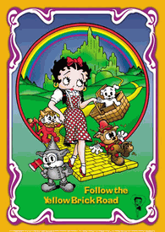
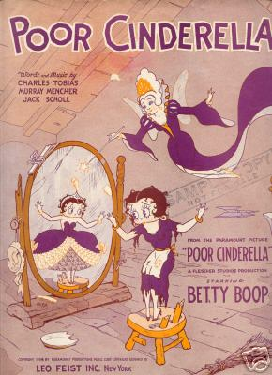
Follow The Yellow Brick Road Cinderella

The Wizard Of OZ
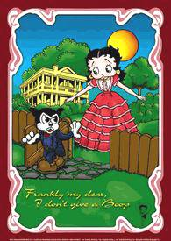

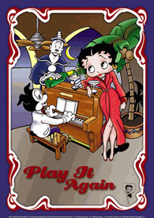

Play It Again Frankly My Dear, I Don’t
Casablanca Give A Boop
Gone With The Wind
