Betty Boop Famous People

Rosie The Riviter Sign Rosie The Riviter Carry Tin
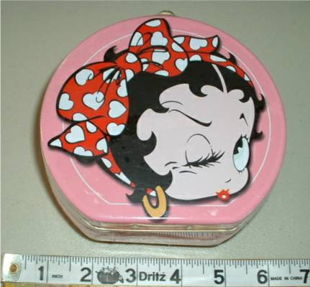


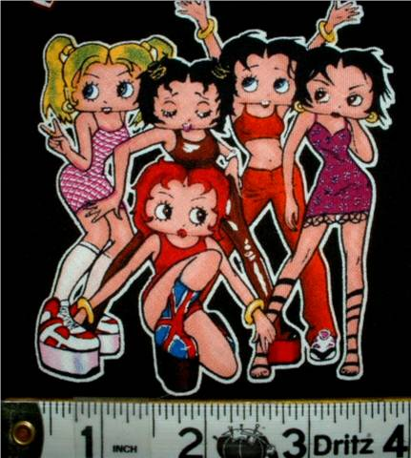

Spice Girls Fabric Statute of Liberty on Fabric

