Betty Boop People II

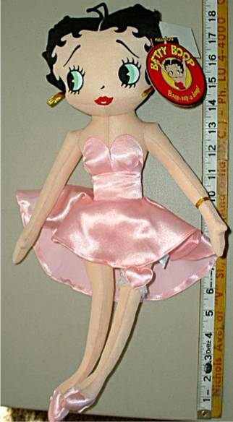
Marylyn Monroe Standup 5’6” Marylyn Monroe Doll


Marylyn Monroe tapestry Marylyn Monroe Postcard

